2024 Cloverbud Skill a Thon Study Guide

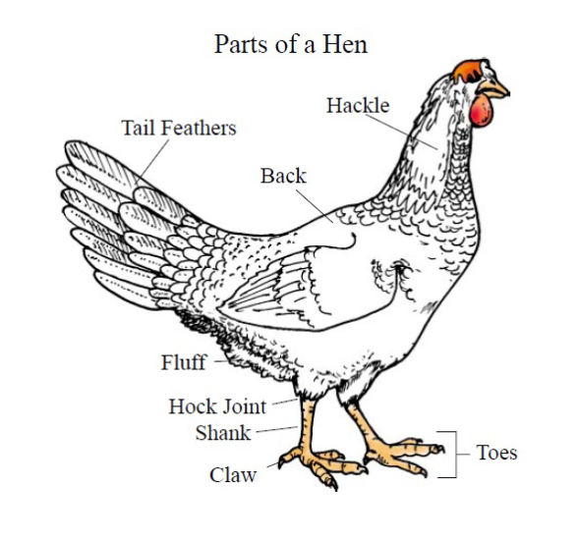

Source: The Ohio State University - https://crawford.osu.edu/sites/crawford/files/imce/Program_Pages/ANR/GrainMrk/Poultry.pdf

