# 2024 Poultry Skill a Thon Study Guide

# INTRODUCTION

This manual has been developed as a study guide for the Florida State Fair Skillathon which is part of the Champion Youth Program. The topic for this year’s Skillathon is **reproductive management**. Animal reproduction has become a complex science that involves a series of physiological and psychological events that must be properly timed and managed. Reproduction has at least three purposes within the animal industry: 1) perpetuation of the species; 2) genetic improvement; and 3) to provide food.

The Florida State Fair recognizes that agricultural education instructors, 4-H agents, parents, and leaders provide the traditional and logical instructional link between youth, their livestock projects and current trends in the animal agriculture industry. **PLEASE NOTE:** This manual is provided as a ***study guide*** for the skillathon competition and should be used as an additional aid to ongoing educational programs.

Sections are labeled **Junior, Intermediate & Senior; Intermediate or Senior; or Senior** to help exhibitors and educators identify which materials are required for each age level.

**\*\***Denotes additional information in the study manual for preparing for the Champion of Champions competition.

The knowledge and skills vary by age group and may include:

**Juniors (age 8-10 as of September 1, 2023)**

Breed Identification

Evaluation and Selection

Gender terminology

**Intermediates (age 11-13 as of September 1, 2023)**

all of the above plus...

Male and Female Reproductive Anatomy

Reproductive Functions

Processing chicks

Reproductive Equipment & Use

**Seniors (age 14 and over as of September 1, 2023)**

all of the above plus....

Breeding Management Practices

Selection: Pedigree/Performance Evaluation

Genomics

**GOOD LUCK!**

**Breed Identification**

**j0325604 Jr., Int., & Sr.**

Poultry breeders select for traits or characteristics that are considered economically important. A purebred animal is one that has the characteristics defined by a breed registry and purebreds are expected to pass those traits on to their offspring with a high degree of predictability. When animals of different breeds are mated, we call it crossbreeding. Crossbreeding produces hybrid vigor which means the offspring outperform the parents. The poultry industry uses crossbreeding to develop hybrid lines for two separate industry segments: layers (egg production) or broilers (meat production). Many people enjoy raising and exhibiting purebred poultry. Some purebred breeds contribute to the commercial egg and broiler chicken industries.

**BREEDS (Purebred Poultry)**

The American Poultry Association “seeks to promote and protect standard-bred poultry in all its phases” (APA website, 2023). They publish a standard of perfection for APA recognized breeds. Breeds are classified by type, class, breed, and variety. Type is either large fowl, bantam, waterfowl, guinea, or turkey. Class is a group of breeds often from a particular geographic region. Breeds are true-breeding groups of birds with defined physical features. Variety is accepted sub-division or variations of color, comb type, etc. within a particular breed.

More information about APA accepted breeds/varieties is available here: <https://amerpoultryassn.com/accepted-breeds-varieties/>.

**BREEDS (with commercial impact):**

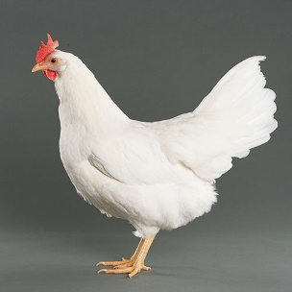**White Leghorn:**

This breed is known for their excellent production of white eggs. Originally, the breed’s ancestors came from Italy, however, over the years many sub-varieties have developed throughout Britain, Europe, and America. This breed has the smallest body size of those listed here. Commercially, it is the major breed used to produce white eggs.

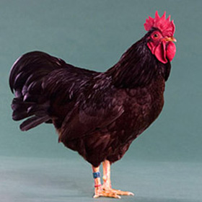**Rhode Island Red:**

This dual-purpose breed has origins in New England where breeders developed the breed by crossing Red Malay Game, Leghorns and Asiatic native stock. This breed is characterized by a long, broad body; a deep, well-rounded breast; color described as a lustrous, rich red throughout; and brown to dark brown eggs. Commercially, this breed has been selected for egg production and is the major breed used by itself or in crosses with other breeds (often called sexlinks due to the ability to determine the sex of the chick by color), to produce brown eggs.

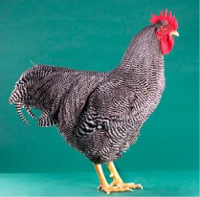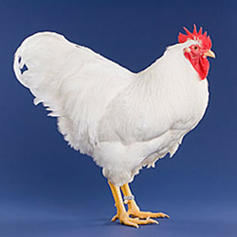**White Plymouth Rock and Barred Plymouth Rock:**

**j0325604 Jr., Int., & Sr.**

This breed comes in seven varieties, including White and Barred. The birds of this breed are known for the brown eggs they produce. This breed is also considered a dual-purpose breed and is the basis for the modern strains of female parent stock for broiler chicks. Commercially, this breed has been selected for meat production and is the major breed used as the “mother” of meat-type chickens.

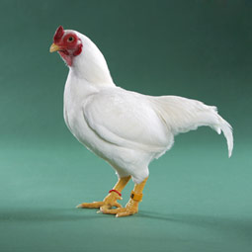

**White Cornish:**

This fowl is uniquely characterized by the texture of their feathers, being short, hard and quite narrow, and by the exceptionally large breast muscles. This breed was produced from White Malay. The shells of their eggs are brown. Commercially, this breed has been selected for meat production and is the major breed used as the “father” of meat-type chickens.

**Strains**

In commercial poultry operations, emphasis is put on either egg production or meat production. Strains of birds of a particular breed or cross have been developed to maximize either egg production or carcass growth and quality. Strains are often products of one individual or company’s breeding efforts. A strain is a breeding population of birds with similar traits of economic benefit. Examples are the DeKalb strain and the Babcock strain of White Leghorn type hens. <https://dodge.extension.wisc.edu/files/2012/02/AQBM-Breeds.pdf>

Explore other poultry breeds with commercial impact in more detail at the following web site:

<https://www.thehappychickencoop.com/best-chicken-breeds-for-business/>

**Gender Names and Terminology**

|  |  |  |  |  |  |  |
| --- | --- | --- | --- | --- | --- | --- |
| **Species** | **Young** | **< 1 year Female** | **Older than 1 year Female** | **< 1 year Male** | **Older than 1 year male** | **Castrated Male** |
| **Chicken** | Chick | Pullet | Hen | Cockerel | Cock/Rooster | Capon |

**Evaluation and Selection:**

**j0325604 Jr., Int. & Sr.**

**Evaluation**

The intended use of the animal will determine which traits are most desirable. Chickens can either be production (commercial) or purebred (exhibition) category. All poultry should be evaluated using your eyes and your hands. All breeds have their own criteria for evaluation, purebred is based on the selected breed and commercial is based on the industrial value. Such as, commercial egg layers are not males since the females lay eggs. Broilers are selected for frame, growth, and carcass quality.

**Selection**

**PUREBRED**

The American Poultry Association Standard of Perfection has detailed descriptions and pictures of the ideal type for each breed and is the official reference for show judges. Breed criteria are based on body type, weight and shape, color of plumage, color of shanks, skin color, color of earlobes and shape and type of the comb. For a better understanding of the breed standard, see the websites below.

Selecting Chickens for Show: <http://mysrf.org/pdf/pdf_poultry/p10.pdf> Purebred (page 3)

<https://amerpoultryassn.com/accepted-breeds-varieties/>

<https://amerpoultryassn.com/2021/11/evaluate-your-birds-two-important-tools/>

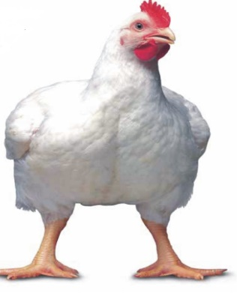

**COMMERCIAL**

Broilers (meat-type) chickens:

* A wide, deep frame (skeleton) is needed for large breast and leg muscle development.
* Strong, straight legs and toes are needed to support the large body.
* The chickens should be alert and have lots of vigor.

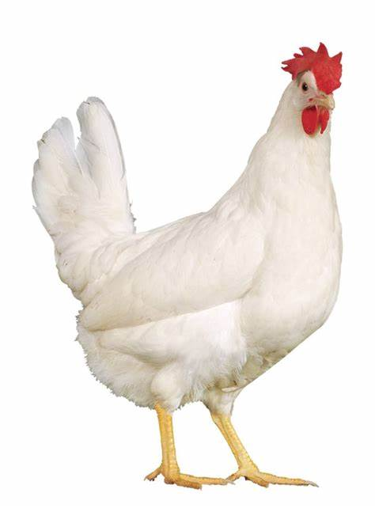 Layers (egg-type) chickens:

* Although mature hens are about half the size of mature meat-type chickens, the frame (skeleton) needs to be of a balanced width and depth to contain the active reproductive system and other internal structures.
* Strong, straight legs and toes are needed to support the hens for about two to four years of egg production.
* The chickens should be alert and have lots of vigor.

**j0325604 Int. & Sr.**

**Reproduction Overview**

**Reproductive Process in Poultry**

The reproductive process in poultry is similar to that in mammals, except the young do not develop inside the body of the female but develop in a fertilized hard-shelled egg that contains all the nutrients needed for chick development. Poultry do not have a gestation period and there is no parturition. Instead, there are *incubation* periods for the different species and *hatching* is the term used for the process of the young getting out of the shell. Poultry refers to about 12 species of birds but this information will focus mainly on the chicken. The length of time required for incubation varies by species and sub species.

Birds differ from mammals in the genetic mechanism by which sex of the offspring is determined. In mammals, sex of offspring is determined by the male gametes (*sperm*), whereas in birds it is determined by the female gametes (*ova)*. This situation results from male birds having two complete sex chromosomes while female birds have only one.

**Reproductive Anatomy**

The unique way birds reproduce determines the type of reproductive tract. Understanding reproductive anatomy is basic to managing reproduction. For additional study visit:

<http://www2.ca.uky.edu/agcomm/pubs/ASC/ASC199/ASC199.pdf>

**Female Anatomy:**

**j0325604 Int. & Sr.**

|  |
| --- |
|  |

**Male Anatomy**

**j0325604 Int. & Sr.**

|  |
| --- |
|  |

**Reproductive Functions**

**j0325604 Int. & Sr.**

Once you know the terms/areas of all the reproductive structures, the next step is understanding the role of each part. Understanding normal functional anatomy allows the manager to apply reproductive management tools.

**Hen Functional Anatomy**

Ordinarily, only the left ovary and oviduct fully develop in the hen. During embryonic development, a right ovary and oviduct begin to develop but then degenerate.

**Ovary** The female gonad produces ova (commonly called yolks) and hormones. The ova develop inside ovarian follicles. When an ovum (yolk) is mature, ovulation occurs. The ovum is released when the follicle ruptures along the stigma; an area of the follicle with very few blood vessels. The hormones, estrogen and progesterone, are produced by the ovary.

**Oviduct** The oviduct has five segments:

Infundibulum: engulfs the yolk after ovulation so it enters the oviduct. It is the site of fertilization if sperm are present in the oviduct as a result of a natural mating or AI (artificial insemination). Sperm are stored here in specialized areas.*

Magnum: secretes egg white (albumen).

Isthmus: secretes the inner and outer shell membranes.

Shell gland (uterus): forms the shell and secretes the cuticle.

Vagina: the passageway for the egg during oviposition; the act of laying an egg as the vagina everts through the cloaca and vent and deposits the egg to the outside. Sperm are stored here in specialized areas near the shell gland.*

* Sperm nest: sperm can survive in the oviduct to provide a high rate of fertility for about 1 week and decreasing fertility rates for about three weeks.

|  |  |  |
| --- | --- | --- |
| Segment | Approx. length, inches | Approx. time spent in egg formation |
| Infundibulum | 3 | 15 min. |
| Magnum | 13 | 2 hr. 45 min. |
| Isthmus | 4 | 1 hr. 15 min. |
| Shell gland | 4 | 20 hr. 45 min. |
| Vagina | 2 | 5 min. |
| Total | 26 | 25 hr. 5 min. |

**Cloaca** Located just inside the vent. The digestive, urinary and reproductive systems connect to the cloaca.

**Vent** Common exterior opening for three systems: digestive, urinary and reproductive.

**Cock Functional Anatomy:**

**j0325604 Int. & Sr.**

A cock comparatively has a simplistic reproductive anatomy to the female. Importantly, male birds do not have a prostate, seminal vesicles, nor bulbourethral gland (Cowper’s gland) as are present in mammals.

|  |  |
| --- | --- |
| **Testicles**  **or testes** | Paired male gonads that produce sperm and the male sex hormone, testosterone. Birds differ from mammals in that the testicles are located inside the body cavity. They are attached near the kidneys. |
| **Epididymis** | The epididymis in birds is very small and does not have a known function as compared to mammals. |
| **Vas deferens** | Long tube connecting epididymis of each testicle to the rudimentary copulatory organ, and transports sperm. |
| **Rudimentary Copulatory**  **Organ** | Organ used for copulation, in birds, that deposits sperm on the hen’s everted vagina. The sperm are enclosed in the vagina as it returns to its normal position. |

**Laying and Hatching**

**j0325604 Int. & Sr.**

**Equipment for Reproduction and Care of Young**

It is important to know different equipment for reproduction and care of young that is used. Following are some ideas of things to be able to identify. There may be others that are not listed so know all possible equipment that is used for practices which are explained in this manual. Livestock supply companies’ catalogs are a good study reference.

|  |  |
| --- | --- |
| Beak Trimmer/Nail Clipper (commercial) | Nesting Box |
| Incubator | Candler |
| Thermometer | Wing Vaccinator |

Needle and Syringe

**Care of Chicks**

After chicks are hatched they should be moved to a brooder, an enclosed area with a wire or litter floor (pine shavings are a good litter). The temperature should be about 95°F for the first week and drop 5° every week after that until the brooder reaches 70 to 75°F. Chicks should be able to move closer to or away from the heat source to get comfortable.

<http://florida4h.org/embryology/brooders.shtml>

Provide day old chicks about 10 square inches of space per chick. This space should be increased by about 10 square inches every two weeks.

Laying pullets can be raised either with range or confinement practices. Confinement takes less space and labor, while predator and parasite losses are lower. Sexual maturity and egg production are affected by light. If the length of day is increased, sexual maturity speeds up. This means the hen will start producing eggs at an earlier age.

Boiler chicks being raised for meat production are usually raised in confinement. Broilers require one square foot per chick of space to a market age of 6-7 weeks. Capons and roasters require 2 square feet of floor space from 7 to 14 weeks of age. When producing broilers, light is usually provided 24 hours a day.

**Capons**

Capons are male chickens that have been castrated. This surgery is usually performed at 3 to 5 weeks of age. The production of capons is very specialized and limited. Most male chickens are not castrated in the United States.

**Beak trimming**

Beak trimming is done in the commercial poultry industry to prevent feather picking and injury to the chickens. Beak trimming is cutting off about a fourth of the upper beak and a fifth of the lower beak. For beak trimming to be permanent, it should be done at 6-8 days of age.

**Vaccinations**

**j0325604 Seniors**

The most common vaccinations for chickens are vaccines for Marek’s disease, Mycoplasma gallisepticum infections, Infectious Bursal Disease, Encephalomyelitis, Fowlpox, Laryngotracheitis, and Newcastle disease/Infectious Bronchitis. Egg producing chickens are often vaccinated for fowl pox at 6 to 9 weeks of age. This vaccination is done by dipping a wing web stick applicator in the vaccine and then pushing it through the wing web. All directions on the label should be followed precisely.

<https://sfyl.ifas.ufl.edu/archive/hot_topics/agriculture/poultry_vaccination.shtml>

<https://www.poultry.care/blog/the-broiler-and-layer-chicken-vaccination-schedule?utm_source=rss&utm_medium=rss&utm_campaign=the-broiler-and-layer-chicken-vaccination-schedule>

<https://thepoultrysite.com/articles/small-flock-vaccination>

**Breeding Management Practices**

**Natural Mating**

The easiest way to breed animals is to let nature take its course. If males are allowed to be with the females, they can find the ones ready to breed. Breeding occurs when the females are in the presence of the males and mating is occurring. Chickens reach puberty at 4-5 months of age.

**Artificial Insemination**

Artificial insemination (AI) is practiced in some situations in chickens, but to a limited extent.  Sometimes it is used by the genetic companies that develop different varieties of egg-type or meat-type chickens.  Artificial insemination (AI) accelerates genetic progress by allowing outstanding males to breed more females than they could with natural mating.  Freshly collected semen does not maintain a high level of fertility for more than about 30 minutes, so it must be used quickly following collection.  This characteristic greatly limits the use of AI with freshly collected semen.  Researchers have developed “extenders”; liquids that are added to fresh semen and extend the time period for high fertility to 6 -12 hours.  It is difficult to get a high level of fertility from chicken semen that has been frozen and stored.

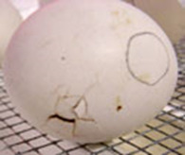<http://www.youtube.com/watch?v=pFXEtUFFgV0>

**Poultry Management Practices**

**Incubation and Hatching**

The first step in incubating eggs is to obtain a fertilized egg. Any chicken egg from a flock where a rooster is kept with the hens should be fertilized. Time, temperature, humidity, ventilation and turning are critical factors to manage. Before being incubated, eggs can be stored up to 7 days without decreasing hatchability when held at a temperature of 55 to 65oF and a relative humidity of 70 to 85%, and for 2 to 3 weeks with decreasing hatchability.

Incubators are used to provide the recommended temperature, humidity, ventilation and turning, if an automatic turner is used. There are two basic types of incubators. These are still-air incubators and incubators with fans. With the still-air incubator the temperature should be kept at approximately 101˚ to 103oF for the first 19 days. With an incubator that has a fan for circulation the temperature should be kept at 99oF. During days 19 to 21 the temperatures should be dropped 1oF in order to compensate for the increased heat produced by embryos.

**j0325604 Seniors**

To control egg weight loss during incubation it is important to add moisture to the air of the incubator. This is done by placing a small pan of water at the bottom of the incubator or keeping water channels appropriately filled. The water should be warm when added to the pan. Egg weight loss is the best indicator of humidity. The egg should lose 12% of its initial weight by three days prior to the expected hatching day. Additional water should be added at the time of hatching to prevent the chicks from sticking to the eggshell. This is started when the first egg pips (when the chick breaks the shells with its beak).

Incubation time varies for different species: 21 days for chickens and 28 days for turkeys and most ducks (some duck breeds can take a few days longer).

Eggs should be turned several times a day from day 1 to 18 to prevent the developing embryo from sticking to the shell and mal-positioning. It also promotes proper development of the embryonic membranes. Eggs should be turned an odd number of times each day; a minimum of three times. Automatic turners usually turn eggs hourly.

Incubators must have openings for ventilation. Fresh air needs to enter the incubator to replenish the oxygen and remove the excess carbon dioxide. The developing embryos need oxygen and produce carbon dioxide. More ventilation is required during the latter part of incubation because the embryos are larger. Maximum ventilation should be used during the last 3 days.

<http://florida4h.org/embryology/incubators.shtml> <http://chickscope.beckman.uiuc.edu/resources/egg_to_chick/procedures.html>

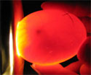

**Candling Incubated Eggs**

Incubated eggs may be candled to determine whether or not they are fertile or to check on embryonic development. The fertility status of un-incubated eggs cannot be determined by candling. To candle an egg, hold the large end up to the opening of the candler. The embryo will be found near the air cell at the large end. Turn the eggs slowly to avoid damaging the embryonic membranes. By the fourth or fifth day of incubation, fertile eggs will look like they have a red spider inside them. These are the blood vessels extending out from the developing embryo. An infertile egg will appear clear with no development. Eggs can be checked throughout incubation to observe the embryonic development. <http://florida4h.org/embryology/candling.shtml>

**Embryology**

The three major parts of the egg are the yolk (ovum), albumen, and shell with the shell membranes. The germinal disc appears as a white spot on the yolk, and it contains the genetic material from the hen. The yolk and egg white are used as a food source by the developing embryo. Fertilization occurs when a sperm unites with the germinal disc. The embryo starts to develop from the germinal disc, if the egg is warmed to about 99.5o F. The yolk provides almost half of the protein and all of the fat required for embryo nutrition. It also contains most of the vitamins and minor minerals required by the embryo.

Egg white (albumen) contains the chalazae, which is made up of protein fibers twisted on the yolk and anchored in the surrounding albumen to stabilize the yolk. The egg white provides slightly more than half of the protein and most of the water required by the embryo.

**j0325604 Seniors**

Surrounding the yolk and albumen are two membranes, the inner and outer shell membranes. The shell is deposited on the outer surface of the shell membranes. Both the membranes and the shell are porous. This allows for oxygen, carbon dioxide, and water vapor exchange. Carbon dioxide and moisture pass from inside the egg to the outside. Oxygen passes from the outside to the inside. Between the shell membranes, a space appears that is called the air cell. The air cell develops as moisture is lost in the egg. The air cell develops as the egg cools and water is lost. The air cell functions as air storage for initial lung respiration just prior to hatching when the chick pierces the air cell and takes its first breath. The shell provides most of the calcium needed for bone formation by the embryo.

|  |
| --- |
|  |
| **Figure 1: Parts of an Egg** |

|  |
| --- |
|  |
| **Figure 2: Embryology** |

**Landmarks of embryonic development**

**j0325604 Seniors**

Rapid development and growth must occur to convert the yolk and egg white into a chick in 21 days. Following are some of the times when certain features are first observed.

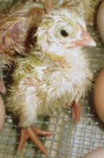

Day 2 Heartbeat begins.

Day 4 Pigment in eyes is visible.

Day 5 Appearance of the reproductive organs and differentiation of sex.

Day 6 Appearance of beak.

Day 8 Feather tracts appear (no feathers).

Day 11 Down feathers become visible.

Day 16 Down feathers cover entire body.

Day 21 Hatching occurs.

<http://chickscope.beckman.uiuc.edu/resources/egg_to_chick/comments.html>

<http://www2.ca.uky.edu/agcomm/pubs/ASC/ASC195/ASC195.pdf>

**The Hatching Event**

After day 19 when eggs are no longer turned, the hatching process begins. The chick begins to absorb the yolk and begins to turn inside the egg 360 degrees. The chick will poke a hole through the side of the egg and begin breathing on their own. This rotation also severs the blood vessels from the egg that were connected through the chick’s naval. This process is important for chicks to be independent from the egg and is why one should not assist a hatching chick. Not allowing this natural process of severing these blood vessels would result in a chick bleeding to death if someone simply removed the shell from the chick rather than allowing it to hatch naturally. This act of hatching also aids the chick in strengthening the muscles it will eventually need to stand. The chicks will then break from the shell. They will soon raise their head, then creep, and eventually summon the strength to stand. Soon they will dry off. A chick that is too weak to hatch is very likely too weak to live.

**Methods for Sexing Day Old Chicks**

Vent Sexing: This method was developed by the Japanese and involves visual examination of the cloaca. The sex is distinguished by minute differences in the anatomy. This method requires extensive training but is highly accurate and rapid once considerable experience is gained. For turkeys and most other domestic species this method must be used because there is no other known method of sexing. The best time for vent sexing is when the chicks are from 12 to 26 hours old. This is a very specialized method only used at large hatcheries by experts. Do not do this at home.

Color-Sexing: The Barred Plymouth Rock breed carries a gene for barring of feathers. It produces a white bar on an otherwise black feather. Barring has been used in cross breeding systems. When a non-barred male is crossed with a barred female, the resulting females will be non-barred like their father, while the males will be barred like their mothers.

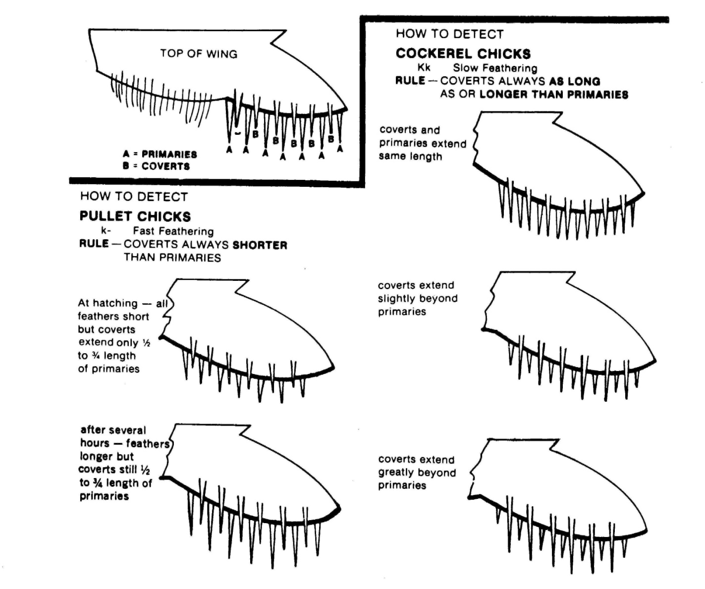Feather-Sexing: The slow feathering gene is the characteristic most commonly used by commercial breeders in the U.S. In this case the sex of the chick is determined by the length of the wing feathers at hatching. A rapid-feathering male is crossed with a slow-feathering female and in the resulting offspring the males are slow-feathering and the females are rapid-feathering. Thus, the males have relatively shorter wing feathers than the females. In the female, the covert feathers are always shorter than the primary feathers. In the male, the covert feathers are always as long as, or longer than the primary feathers.

**j0325604 Seniors**

<https://poultry.extension.org/articles/poultry-management/sexing-day-old-chicks/>

**Selection: Pedigree/Performance Evaluation**

Proper selection is a critical factor in establishing a good breeding program. The goal of animal selection is to produce an animal that will yield/produce high quality products at a low cost to the farmer and the consumer. This goal is the foundation of the standard “ideal animal” in the various species. That is, the animal that expresses, to the highest degree, traits that are of economic importance like clutch size, body weight, egg production, carcass merit or even color is the type selected.

The expression of observable or measurable traits is called the animal’s *phenotype*. Phenotype is affected by both heredity and environment. The inherited portion of a trait is referred to as *genotype*. How well an animal expresses the genotype is affected by the environment in which it A black and white picture of a rooster
is raised. Therefore, when making a selected mating, use and management of the offspring should be considered. We use both visual appraisal and performance records when selecting breeding stock.

**Performance Evaluation**

How an animal looks may be important at the show but how that animal performs is more important to the farmer. With advancements in the understanding of heredity and the increased use of computers for keeping records, the use of genetic information in a selected mating has become easier. By keeping records on desirable traits and then carefully selecting males and females to be mated using the available data, producers can improve the genetics, and thus the performance of their offspring.

There has been extensive selection for growth rate, feed efficiency and meat yield in broilers (meat-type chickens) and turkeys. Egg-type chickens have been extensively selected for egg numbers, egg weight, shell strength and feed efficiency. Tremendous improvements in these characteristics have been made through selection programs and the associated performance evaluation.

**Estimating Past Egg Production**

A measure of reproductive performance (number of ovulations) in hens of certain breeds of chickens can be estimated by observing certain external characteristics. In birds, ovulation results in an egg being formed and laid to the outside of the body where it can easily be gathered and counted. In yellow-skinned chickens which have been fed ingredients containing xanthophyll pigment (such as yellow corn), the pigment bleaches from the pigmented areas in a definite order according to the approximate number of eggs the hen has laid. Thus, hens can be ranked on their estimated past egg production, based on bleaching; the more the bleaching the more eggs have been laid. When hens begin to lay eggs at puberty, the pigment bleaches in the following order: vent, eye ring, ear lobe, beak, bottom of feet, and shanks.

<https://national4hpoultry.ca.uky.edu/pastproductionhens>

**Judging Past Production Hens**

**j0325604 Seniors**

Judging is done by comparison, that is comparing each hen to the others in the class. Certain characteristics are used to estimate the number of eggs each hen has laid. Hens are ranked with the top hen being the one estimated to have laid the most eggs. If possible, place hens based on loss of pigment (bleaching) from the skin. It is assumed that the more bleached a hen has become, the more eggs she has laid. Compare the amount of pigment in the skin of the hens. The hen that has the least pigment should be placed first, and so forth according to the amount of pigmentation.

If a pair of hens has equal loss of pigment, then use abdominal capacity to decide which hen is best. A wide distance between the bottom of the pubic bones and the rear tip of the keel bone, in addition to a wide distance between the pubic bones, means good abdominal capacity and is desirable.

If a pair of hens has equal loss of pigment and equal abdominal capacity, then use abdominal fat coverage (this used to be referred to as handling qualities) to decide which hen is best; the better handling quality (least amount of abdominal fat coverage), the better the hen. A lean, trim condition of the pubic bones, skin and abdomen means good handling quality/least abdominal fat coverage.

If a pair of hens has equal bleaching, abdominal capacity, and equal abdominal fat coverage, then use molt condition to decide which hen is best. A hen that is not molting (losing and replacing feathers) or that has molted the fewest primary feathers is desirable.

To learn about judging past productions hens, visit:

<https://www.youtube.com/watch?v=ef2b1sI7EjI>

<https://www.youtube.com/watch?time_continue=3&v=CaexZ3NRzJs>

|  |  |  |
| --- | --- | --- |
|  |  |  |
| FIGURE 3: No Bleaching | FIGURE 4: Moderate Bleaching | FIGURE 5: High Bleaching |

**Genomics**

**j0325604 Seniors**

Genomics is the study and mapping of a species or individual animal’s genome, or all of the animal’s genes and their interactions with one another. The expression of the genome is what one sees in the animal’s phenotype or performance/appearance. In short, genomics is the study of an animal’s DNA. DNA, or deoxyribonucleic acid is composed of two polynucleotide chains that coil around each other to form a double helix. The chain contains the genetic instructions for the development, function, growth and reproduction of an organism. For the purposes of animal agriculture, the genome also influences (along with nutrition, health, environment, etc.) the animal’s quality and quantity of meat, reproductive life, growth rate, heat tolerance, and about any other trait one can imagine. Understanding the blueprint of a particular animal at the genetic level by studying the animal’s genetic code has immense ramifications for animal agriculture. Livestock genomics is an emerging field in which breeding sires and dams with specific genes which directly influence specific traits is possible (muscling, marbling, egg production, sexual maturity, etc.). Over the past 20 years the use of genomics has emerged in livestock and poultry production. Unlike simple genetics, genomics studies the entire genetic makeup including all of the interactions of each gene with all the other genes in an animal. Producers can utilize genomic testing to predict future profitability. To this point, the genome of just about every major livestock specie has been mapped, including cattle, goats, sheep, swine, rabbits, and poultry. Genomics is currently primarily used as a tool to make decisions on selected breedings to result in offspring with targeted genetics. The potential for editing genes to produce offspring with targeted traits exists but is not currently utilized because the regulatory frameworks are still being developed. Still, genomics is among the latest cutting-edge technologies in animal agriculture and animal reproduction management.

Here are some web pages highlighting some work in poultry genomics:

<https://www.thepoultrysite.com/articles/future-of-genomics-in-poultry-breeding>

Sources:

<https://www.mdpi.com/journal/agriculture/special_issues/livestock_genetics>

<https://www.frontiersin.org/articles/10.3389/fgene.2019.00327/full>

<https://www.illumina.com/content/dam/illumina-marketing/documents/products/technotes/technote_ag_genomic_selection.pdf>