Scoring System
Each section of this Record Book will be scored by the judge based on the completeness and accuracy of that section. You must initial the bottom of each page where there is an initial line in order for that page to be counted in your final score. This record book is not included as a part of your overall Member Record Book Score.

Section | Item | Points Possible
Cover | Signatures | 3
I | Plans and Goals | 10
II | Officer Achievements | 12
III | Treasurer’s Records (Found in the Treasurer’s Manual & Record Book | 50
IV | Project Pictures | 20
 | Overall Neatness, Accuracy, Grammar & Spelling | 5
 | Total Possible Points for Project Record Book | 100

Ribbon Awards

Blue: 90% - 100%
Red: 80 - 89%
White: 79% - 0%

P a g e |
Florida 4-
H Treasurer’s Manual,
Page
4
H GCR
02

A Resource for 4-H Club Treasurers
Reviewed: 01/2022
The Role of the 4-H Club Treasurer ......................................... 3
Club Budget
Club Budget ................................................................................. 4

Income and Expenses
Club Income
Club Dues ............................................................................ 5
Club Fundraising ................................................................. 5
Club Donations ................................................................... 6 Grants .................................................................................. 6
Fundraiser Planning Guidelines ......................................... 7
Fundraising Permission Form ............................................ 8
Receiving Money ........................................................................... 9 Making Deposits ......................................................................... 9
Club Expenses ........................................................................ 10

4 -H Treasurers Record Book
The Treasurer’s Report ................................................................. 11 Treasurer’s Checklist .................................................................... 11 Club Budget Outline ..................................................................... 12 Check Reimbursement Request ................................................... 13
Monies Received Form ................................................................. 15
Record of Club Dues ..................................................................... 17
Monthly Ledgers ........................................................................... 19
Annual 4-H Club Financial Summary .......................................... 29

Appendix
Glossary of Financial Terms ......................................................... 30
Florida 4-H Treasurer’s Book References .................................... 31

Congratulations on being your Club’s Treasurer!
Being the treasurer is a very important position in your club. Your fellow 4-H Club Members have shown their confidence in you by letting you have this responsibility. As treasurer, you will be responsible for taking care of the club’s money, bank accounts, or other money matters.

Let’s take a closer look at your duties ...
- Attend 4-H officer training if one is available. If not, review your duties with your club leader.
- Chair your club finance and fundraising committees. Use the committee to involve members in the decision making, as well as in accomplishing the business of the committee. The finance committee is responsible for developing an annual club budget.
- Keep an accurate account of:
  - all money received and its sources.
  - paid expenses showing to whom and why the money was paid.
- Learn how your County 4-H Association works, and about your responsibility as a club treasurer in working with the Association.
- Review the Treasurer’s Summary from the previous year.
- Prepare and present a summary of income and expenses at each club meeting– called the Monthly Treasurer’s Report. Also, report the current balance of all club accounts. Keep your monthly ledger for income and expenses up-to-date.
- Deposit dues (if any) and any other money received as soon as possible to the club account with the help of your 4-H club leader. Use the “Monies Received Form” in this book to list and attach cash and checks you receive.
- Use the Forms at the back of this book to help you follow rules and manage the Club’s funds.
- Use the “Fundraising Permission Form” to request permission to conduct a Fundraiser with your County 4-H Association.
- Ask permission from your County 4-H Association before your club writes a grant . And follow all grant policies.
- Give receipts to all individuals who have provided money for the club.
- Pay money out of the club account only as voted by the club. A “Check /
Reimbursement Request Form” will need to be completed and submitted to your County 4-H Agent or Association/Foundation Treasurer.
- If the club has any bills, make sure they are paid promptly.
- Fill out and turn in the “Annual 4-H Club Financial Summary” at the end of the year.
- Take responsibility for the club funds until the next club treasurer is elected. In the event a 4H club disbands, the funds in the club treasury must be either transferred to another chartered 4-H club or else donated to the county 4-H program.

At the beginning of each year, club officers should sit down with the club members and
determine what types of projects and activities they would like to do during the year. After you
have decided what the club would like to do, you need to develop a club budget.
A
budget
includes estimated income and expenses for the year. By doing this, you can see how
much money your club needs. The budget should be developed by you, the club treasurer, with
the help of a
budget/finance committee
, and the guidance of your club leader. The budget/
finance committee may be composed of club members or club officers.
Use the following questions and budget outline on page 12 to develop your club budget:
- How much money does the club have now? $____________
This is your “balance on hand” or beginning balance for the year.
- What activities are being planned by the club during the coming year (club trip, community service activity, etc.)? Beside each activity put an estimate of how much money will be needed for the activity.
- Make a list of club projects that have adult or teen leaders (dairy, clothing, etc.). Ask each leader what their plans are and how much money they will need to carry out their planned project activities. Write this amount next to each project.
- What county or state events will members be participating in during the coming year (summer camp, Florida 4-H University, state fair, etc.)? How much should the club provide for members who otherwise could not go?
- Do any of the club officers have any expenses? For example – picture printing costs for the club reporter or historian, or do you plan to buy jackets or t-shirts this year?
- What about club awards (officer pins, end-of-the-year recognition for club members, etc.)? What about meeting expenses?
- What fundraisers are your club participating in and how much do you expect to raise from them? Is your club charging its members dues, and if so, how much?

Let’s take a closer look at the pieces that make up your budget. As club
treasurer, you are responsible for all the money that comes into and goes
out of your club.
The money that comes in to your club is called “income,” and the money that your club pays out is called your club’s “expenses.”
Income is money you receive from things such as dues, fund-raisers, and donations. Expenses are things that your club pays for -such as supplies for meetings or projects and scholarships.

There are four types of income - club dues, fundraisers, donations and grants. Let’s look at each more closely.

- Club Dues
The most common type of income you will receive is club dues. Many 4-H Clubs charge members dues. This gives the club money to participate in group projects and do the activities they want to do. So where do club dues come from? Your club dues may be set in your club’s by-laws or annually by your club membership as you prepare your annual club budget. Try to keep dues low and instead, look at alternative ways, such as fund-raising to earn income.

- Club Fundraising

Fundraising is a great way for your club to generate income for planned activities. Fundraisers should be fun for all of the members, as well as profitable. The club, under your leadership as treasurer, should come up with ways to raise money. This part is challenging, yet fun.

There are many things you should consider when planning a fundraiser. A complete list of these rules and other guidelines you should follow when doing your 4-H Club Fundraiser are on the next page along with a Fundraising Permission Form. Always check with your county 4-H Office for specific county policies, procedures and required forms.

Here are some questions to assist you and the club in deciding how to raise money:
  - Based on your club’s planned program, how much money do you need to raise?
  - Will there be one major fundraiser or several different smaller ones?
  - Who will have the responsibility of coordinating each fundraiser? In many organizations this is the treasurer’s responsibility and he/she often has help from the finance committee. Or your club could set up a fundraising committee with you or another member as the chairperson.
  - What will be the fundraiser(s)? Brainstorm for ideas at a club meeting or with your
Below are ideas for a fundraiser, but your club does not have to limit its ideas to this list:

Auctions Garage/Yard Sales
Babysitting Homemade Crafts
Bake Sales Walk-a-Thon
Bike-a-Thon Car Washes
Holiday Decorations Dances
Product sales

Note: Individual 4-H youth, 4-H volunteers, 4-H clubs, and County 4-H Associations are permitted to conduct fundraising online by using
“crowdfunding” or “crowdsourcing” web sites if all money raised for 4-H purposes follows current 4-H policies and best practices, especially those pertaining to fundraising.

3. Club Donations

Your club may receive donations in support of 4-H. Donations can include cash and non-cash gifts. Non-cash gifts are goods or services when no cash is exchanged, such as a gift of property or time. When the gifts are considered small ($100 or less in value), the club may coordinate the process. However, if the value of the gifts exceeds $100 or if the person would like to receive a documenting letter for a tax benefit, then your club should seek help from the County Extension Office. For more information on fundraising and receiving donations/gifts, see the Fundraising Fact Sheet: Procedure for Handling 4-H Accounts: Guidelines for Fund-Raising (DLN 4H 255) availa-

4. Grants

Grants are another way for your club to fund planned activities. However, it is very important that your club understand what a grant is and how the money can be used. A grant is money given in return for action promised. In other words, a specific amount of money is given to your club with the understanding that it will be used only for an agreed upon purpose. If your club does not use the money for the agreed upon purpose, the money must be returned. It is important to understand that grant requests must be approved through the county Extension office and that neither a member or club leader can sign a grant or a contract.
Grants are often one-time allocations that can be used to start a program or project. Very few grants are renewable. While grants can play a vital role in starting a new program or helping maintain a new program for a short period of time, it may be a better use of your time and effort to find renewable sources of income for your club.

Fundraiser Planning Guidelines

For detailed information on Fundraising policies please check out the 4-H policies webpage at florida4h.org/policies/#funds

It is important to estimate the amount of money your club will raise from a fundraiser. Pre-approval is needed in order to start a fundraising activity. This form may look like the sample on the next page. Check with your county extension office to see if there are limits on how much you can raise and if there are any special restrictions on extremely large fundraisers.

- Raise funds with a purpose. In other words, only raise money if it is needed and will be used for a specific educational project. It is not just to add funds to your club account.

- Get approval. Before using the 4-H name or emblem (green four-leaf clover with a white “H” on each clover leaf) on products club members have made or produced, contact your local extension office for approval. DO NOT put the 4-H name or emblem on commercial products your club is selling as a fundraiser, unless it has been approved. Review the Fact Sheet for regulations on using the 4-H Name and Emblem, which is available online on the 4-H policies webpage.

- Also, seek any other approvals needed by your county.

- Plan effectively. Plan the fundraising activity so that the customer will receive value for the money they spend and your club members can have fun. Raffles and games of chance should be avoided.

- Promote it. Once you have decided on a fundraising activity, get the word out! Inform the public and potential customers of the fundraiser. Make sure to answer these questions:

- What is the name of the event? County Auction, Holiday Dance, Car Wash
- Who is selling the product or performing the service? Your 4-H club
- What are you raising money for? camp, community service project
- When and where will the fund-raising event take place? date, time, location, approval to use location
- Why you are raising money? Share how it will benefit the community.

- Keep it a learning experience. In addition to raising money, a fundraiser should also help club members to get to know each other better, learn about budgeting and using resources. It can also help your club become more visible in the community– and depending on the reason for the fundraiser seen as contributing to community needs. Think about various leadership roles members can take to plan and conduct the fundraiser (i.e. marketing, recognition, quality control, sales chair or others as identified).

- Account for all money. Remember that as club treasurer, you are responsible for collecting and depositing money raised by the activity, for paying any bills, and for properly recording the receipts and expenses from the fund-raiser. You should record any money deposited into the club bank account in the account ledger and in the correct Monthly Ledger for Income and Expenses found at the back of this book. Be sure to write a receipt for the funds once the activity is over.

APPLICATION FOR APPROVAL OF FUNDRAISING ACTIVITIES
4-H CLUBS OF MANATEE COUNTY
Please return this application to the 4-H Office at least ₇ days before proposed fundraising activity.
Name of Club: Date: _____________________
Organizational Leader: Phone: ___________________
Address: ________________________________________________________________________
PROPOSED FUNDRAISING ACTIVITY
Date: Time: ___________________________________
Location(s): ___________________________________________________________________________
Name of Adult Supervising Activity: ________________________________________________________ Description of Activity: (Include type, how selected, and names of persons and/or organizations involved.)_______________________________________________________________________________
_______________________________________________________________________________________
_______________________________________________________________________________________
_______________________________________________________________________________________
Purpose of Activity: (Please explain why you are conducting this fundraising activity and exactly what the proceeds will be used for.)
_______________________________________________________________________________________
_______________________________________________________________________________________
_______________________________________________________________________________________
_______________________________________________________________________________________
Requested by: Date: _______________________
Organizational Leader’s Signature
Approved by: Date: _______________________
4-H Agent’s Signature, aldraper@ufl.edu
Please return this application to: 4-H Youth Programs, 1303 17th Street West, Palmetto, FL 34221
Adapted from Michigan State University Extension - Oakland County: dls:fundraisingapproval 10/06/00
Florida 4-H Treasurer’s Manual, Page 8
4-H Financial Check Request
Date Check Written | Check Number | Agents Approval | Foundation Approval
Club/Program Name: _______________________________ Event/Activity Name: _________________________
Make Check Payable To: ___________________________________ Amount: $ ___________________________
Mailing Address: ________________________________________________________________________________
________________________________________________________________________________
Special Instructions (Mail/Hold for pick up/Mail to different address):
______________________________________________________________________________________________
Reason for withdrawal: __________________________________________________________________________
______________________________________________________________________________________________
______________________________________________________________________________________________
4-H Club Leader Signature: _______________________________________________________________________
4-H Club Officer Signature: _______________________________________________________________________
Instructions:
- All receipts MUST be originals. Exceptions to that rule would apply if you cannot mail or drop the withdrawal off at the 4-H office and emailing is your only option.
- All receipts MUST be signed or initialed by the person requesting the reimbursement. This applies to emailed receipts too.
- Receipts MUST equal the exact dollar amount being requested. Estimates are not acceptable without proper documentation.
- Check requests MUST include documentation proving the purchase was approved by the club/program.
Documentation may include: Club or foundation bylaws, budget, or meeting minutes stating that funds were approved. Said withdrawal cannot exceed allowable approved budget or minutes without written club approval.
- Withdrawals MUST be submitted to 4-H within 60 days of the transaction or activity.
- All transactions MUST be specific to ONE activity or expense. i.e., Reimbursement for a club party expense cannot be submitted in the same reimbursement request with another event or activity.
- All receipts MUST NOT have personal items mixed in with 4-H expenses.
- All club fund withdrawals MUST have a 4-H club leader signature AND a 4-H club officer signature. These two people CANNOT be related, and the form CANNOT be signed by the person receiving the check.
Office Use Only:
4-H Staff Signature: ___________________________________________ Date: ____________________________
Date check was released: _______________ Checkbook: ____________ Scanned: ____________ Uploaded: ____________
Updated 7/27/2023
Florida 4-H Treasurer’s Manual, Page 9
.
Expenses are things like supplies for meetings and projects, scholarships to 4-H events, that have an educational purpose that are part of your planned program. So how do you pay for all of these things? With your income, of course. A part of the Treasurer’s job is knowing what your club can and cannot pay for before making a request to use Club funds for expenses.
Check with your 4-H agent to determine if there are things you cannot spend your money on.
Filling out the check/reimbursement request form is the way you will pay for things out of your club’s account. Make sure you have the correct check request form from your County 4-H Association and that all receipts are attached (or use the one on page 13). Follow the instructions your County 4-H Association provides to know how far in advance you must request a check before it will be mailed to you.
Remember:
- - Record all income in your Monthly Ledger at end of this book.
- Report at club meeting all monthly expenditures and income.
3- When the County 4-H Associations Treasurer sends you your monthly statement, you need to balance the statement against what you have entered in the monthly expense ledger.
Florida 4-H Treasurer’s Manual, Page 10
Now that you understand club budgets, income, and expenses, it is important to learn how you keep track of all of these transactions. This Treasurer’s Book provides forms for you to create a budget, request checks to be written, and list funds that have been received and need deposited. This record book also provides forms for you to record dues and a Ledger for you to record income and expenses.

THE MONTHLY TREASURER’S REPORT
As the treasurer, it is your job to keep the members up-to-date on how the club is doing financially. You can measure this by writing each income and expense in the Monthly Ledger. At each club meeting there should be a place on the agenda for the Treasurer’s report. You should inform members of the beginning balance, all of the expenses paid, all of the income brought in, and the ending balance. This should be verified with the bank statement of the County 4-H Association. After the report the club votes to approve the report, then this becomes part of the official records of the club and attached to the monthly ledger of expenses and income.
At the Beginning of the Year….
- Attend 4-H Officer Training if offered
- Meet with club members to set goals and set a budget for the year.
- Review the Treasurer’s Summary from the previous year.
Weekly…
- Collect dues
- Make sure that all bills are paid.
- Deposit all money with the County 4-H Association. Send “Check/ reimbursement Request Form” to the County 4-H agent or the County 4-H Association Treasurer.
Monthly…
- Record all monies received and expenses in the ledger.
- Share with club members the club financial balance or your Treasurer’s Report.
At the End of the Year…
- Turn in the “4-H club financial summary” with the County 4-H Association.  Sign over the books to the new treasurer.
*Filing with the IRS- all forms unless a special club exemption form is in order, will be filed for the clubs by the County 4-H Association.
Florida 4-H Treasurer’s Manual, Page 11
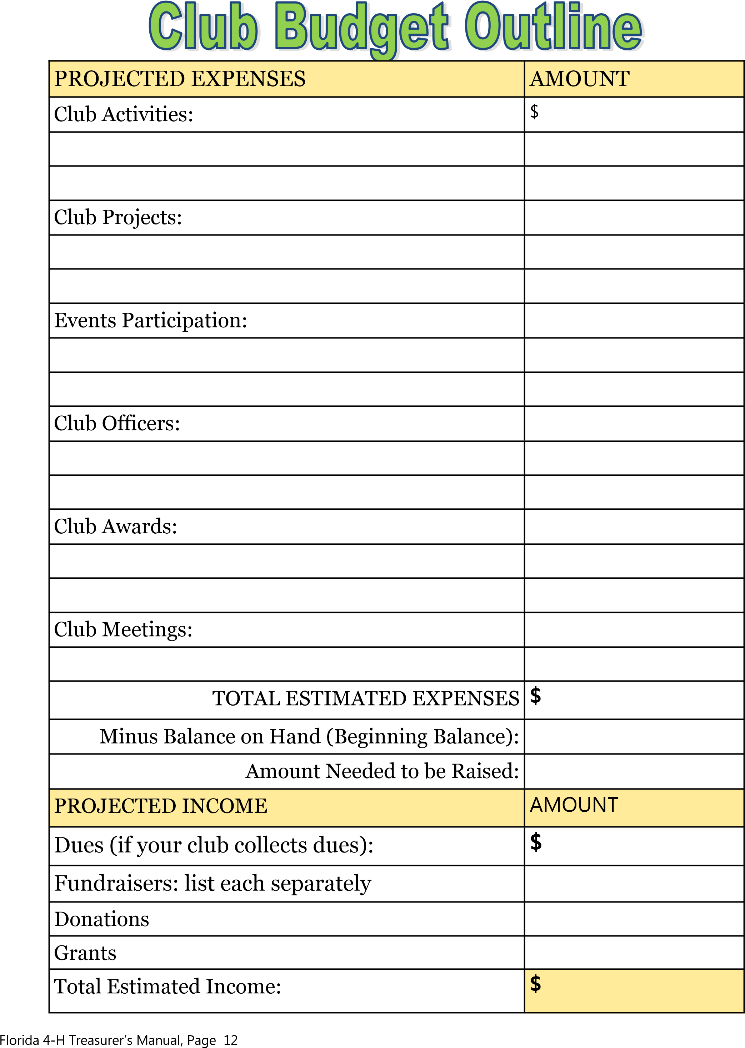
4-H Financial Deposit
Club/Program: __________________________ Event/Activity: ___________________________
Check(s): $_____________________________ Cash: $_________________________________
Receipt #: ______________________________ Total Deposit Amt. $_______________________
Signature of Depositor: ____________________________________ Date: ____________________
Reason: ___________________________________________________________________________
__________________________________________________________________________________
__________________________________________________________________________________ __________________________________________________________________________________
Note:
- All deposits MUST be submitted within 5 business days of the date when the funds were collected. Deposits that are $1000.00 and up MUST be turned in to the 4-H Office within one (1) business day of the event or activity.
Deposits must be signed/initialed by the person delivering the deposit to 4-H. I.e., a club leader, youth member, volunteer, etc.
- If the funds being deposited were collected from multiple individuals (I.e. items sold at a club fundraiser, event registrations, money collected from individuals to buy club t-shirts):
    - The deposit must include a log of the payments collected. The log must include Title of the Activity, date(s), and amounts collected from each individual. The log must be signed/verified by two people working the event/activity (4-H members or volunteers).
    - OR individual receipts can be given to the buyer/donor and the carbon copies need to be included with the deposit. Each receipt must include the Received From Name, ($) Dollar Amount, Reason, and be signed by the person who is writing the receipt.
Office Use Only:
4-H Staff Signature: _____________________________________ Date: ___________________
Date Deposited: _________________Checkbook: _______Scanned: _______Uploaded: ________
Updated 7/27/2023 Florida 4-H Treasurer’s Manual, Page 13
Florida 4-H Treasurer’s Manual, Page 14

______________________________________ _______________________________________
4-H Club Date
Cash | Name |  | Purpose |  |  | Amount
 |  |  |  |  | Total Received
Check # |  | Name |  | Purpose |  |  | Amount
 |  |  |  |  | Total Received

_______________________________________
Treasurer Club Leader
For __________ County 4-H Association Use Only:
Date Received: ___/____/____ Amount Verified by: ________________________ Category:__________ Florida 4-H Treasurer’s Manual, Page 16
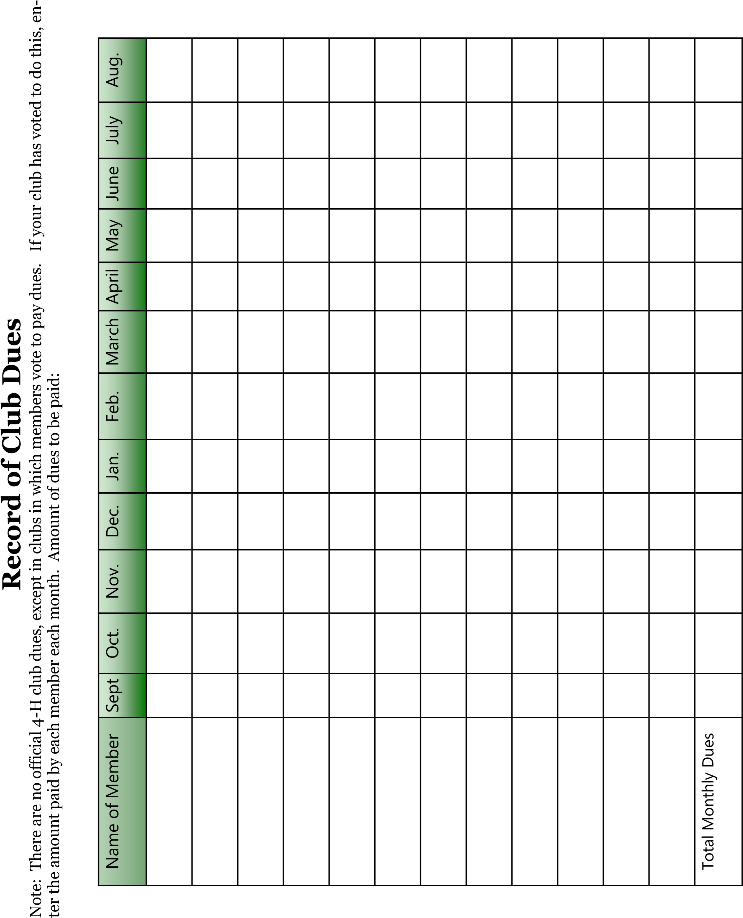

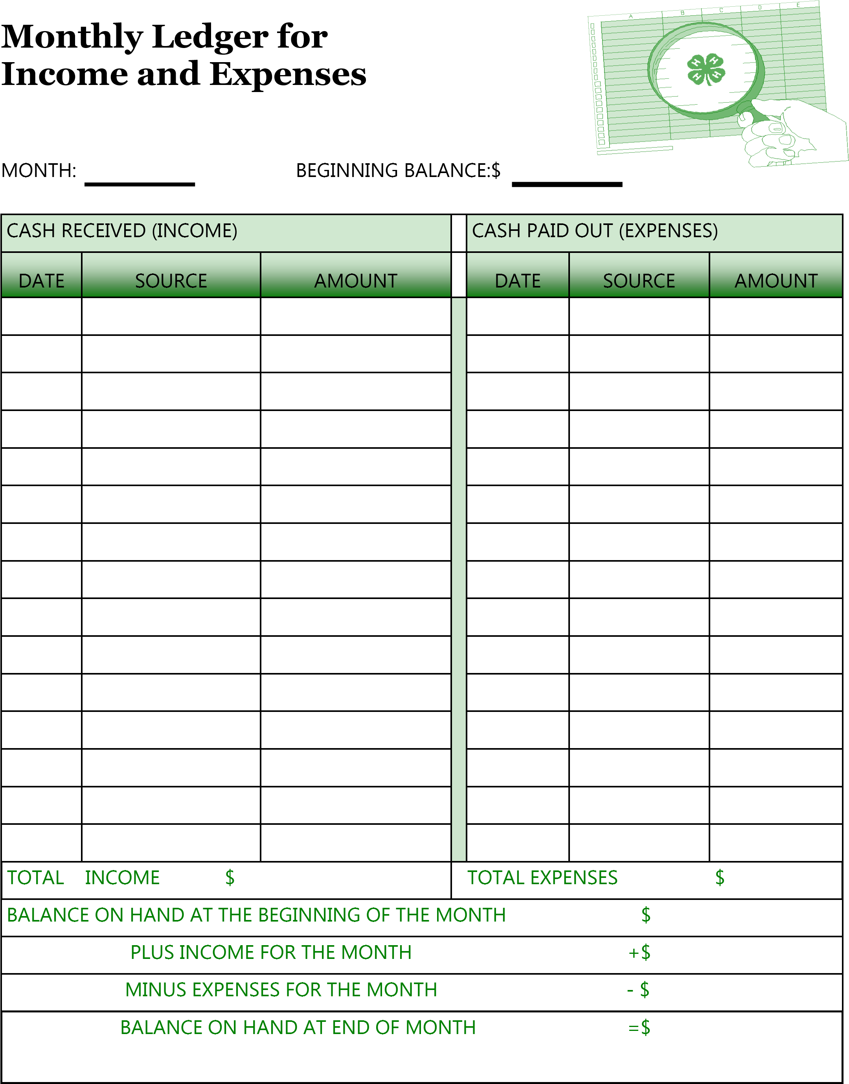
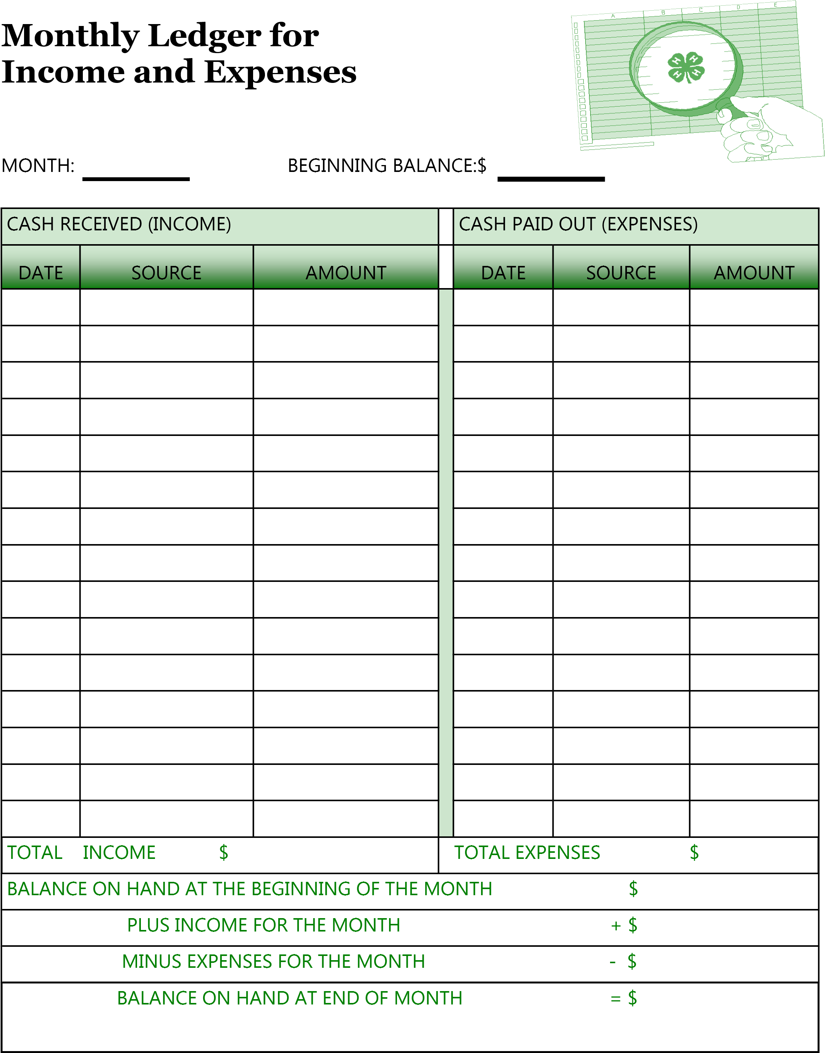

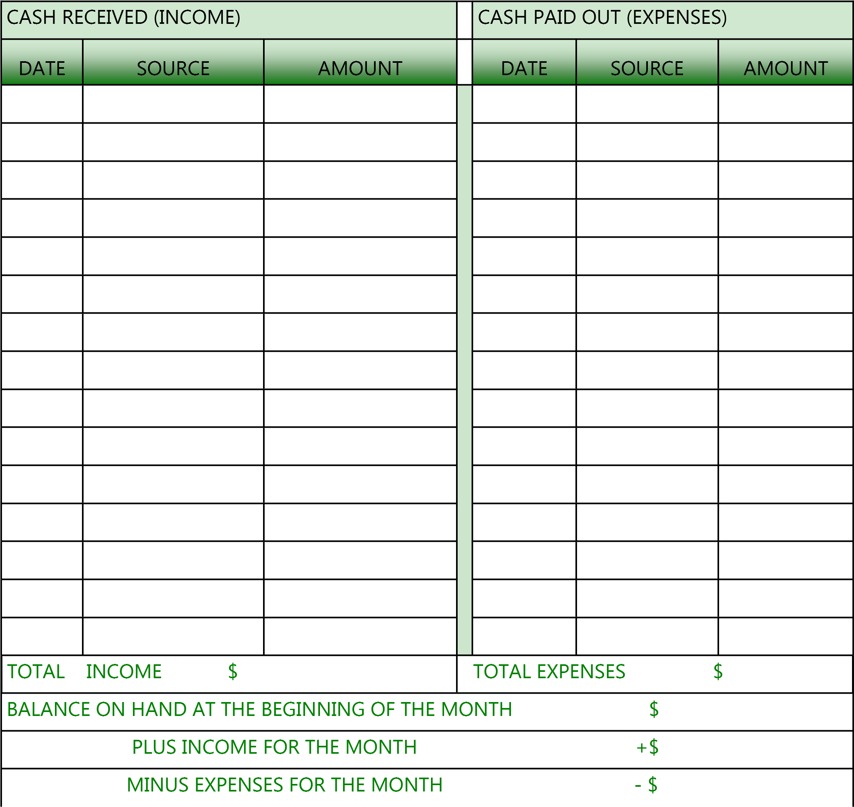
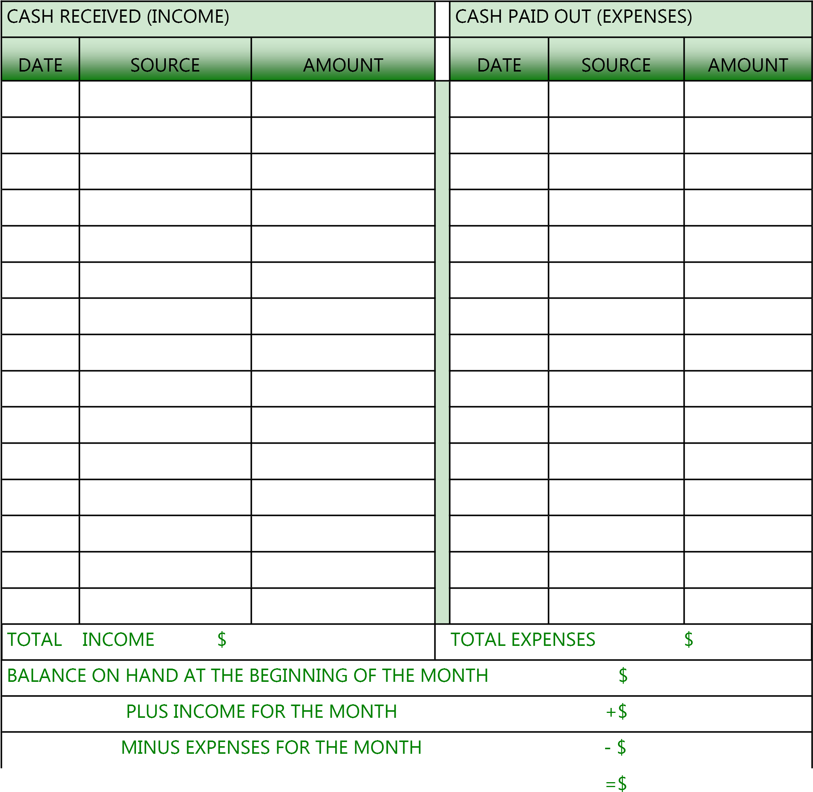
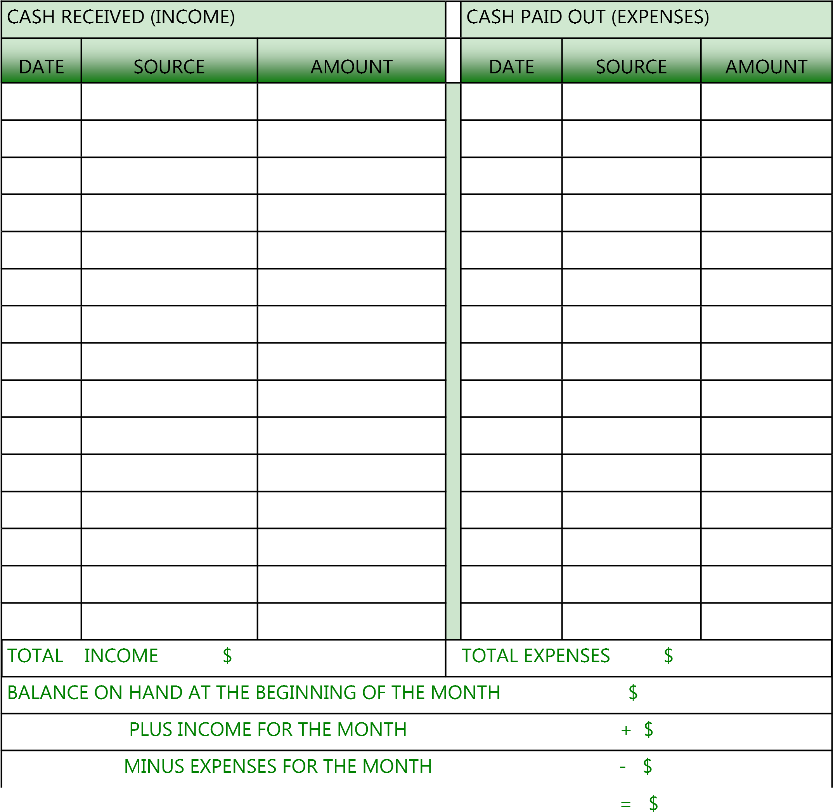
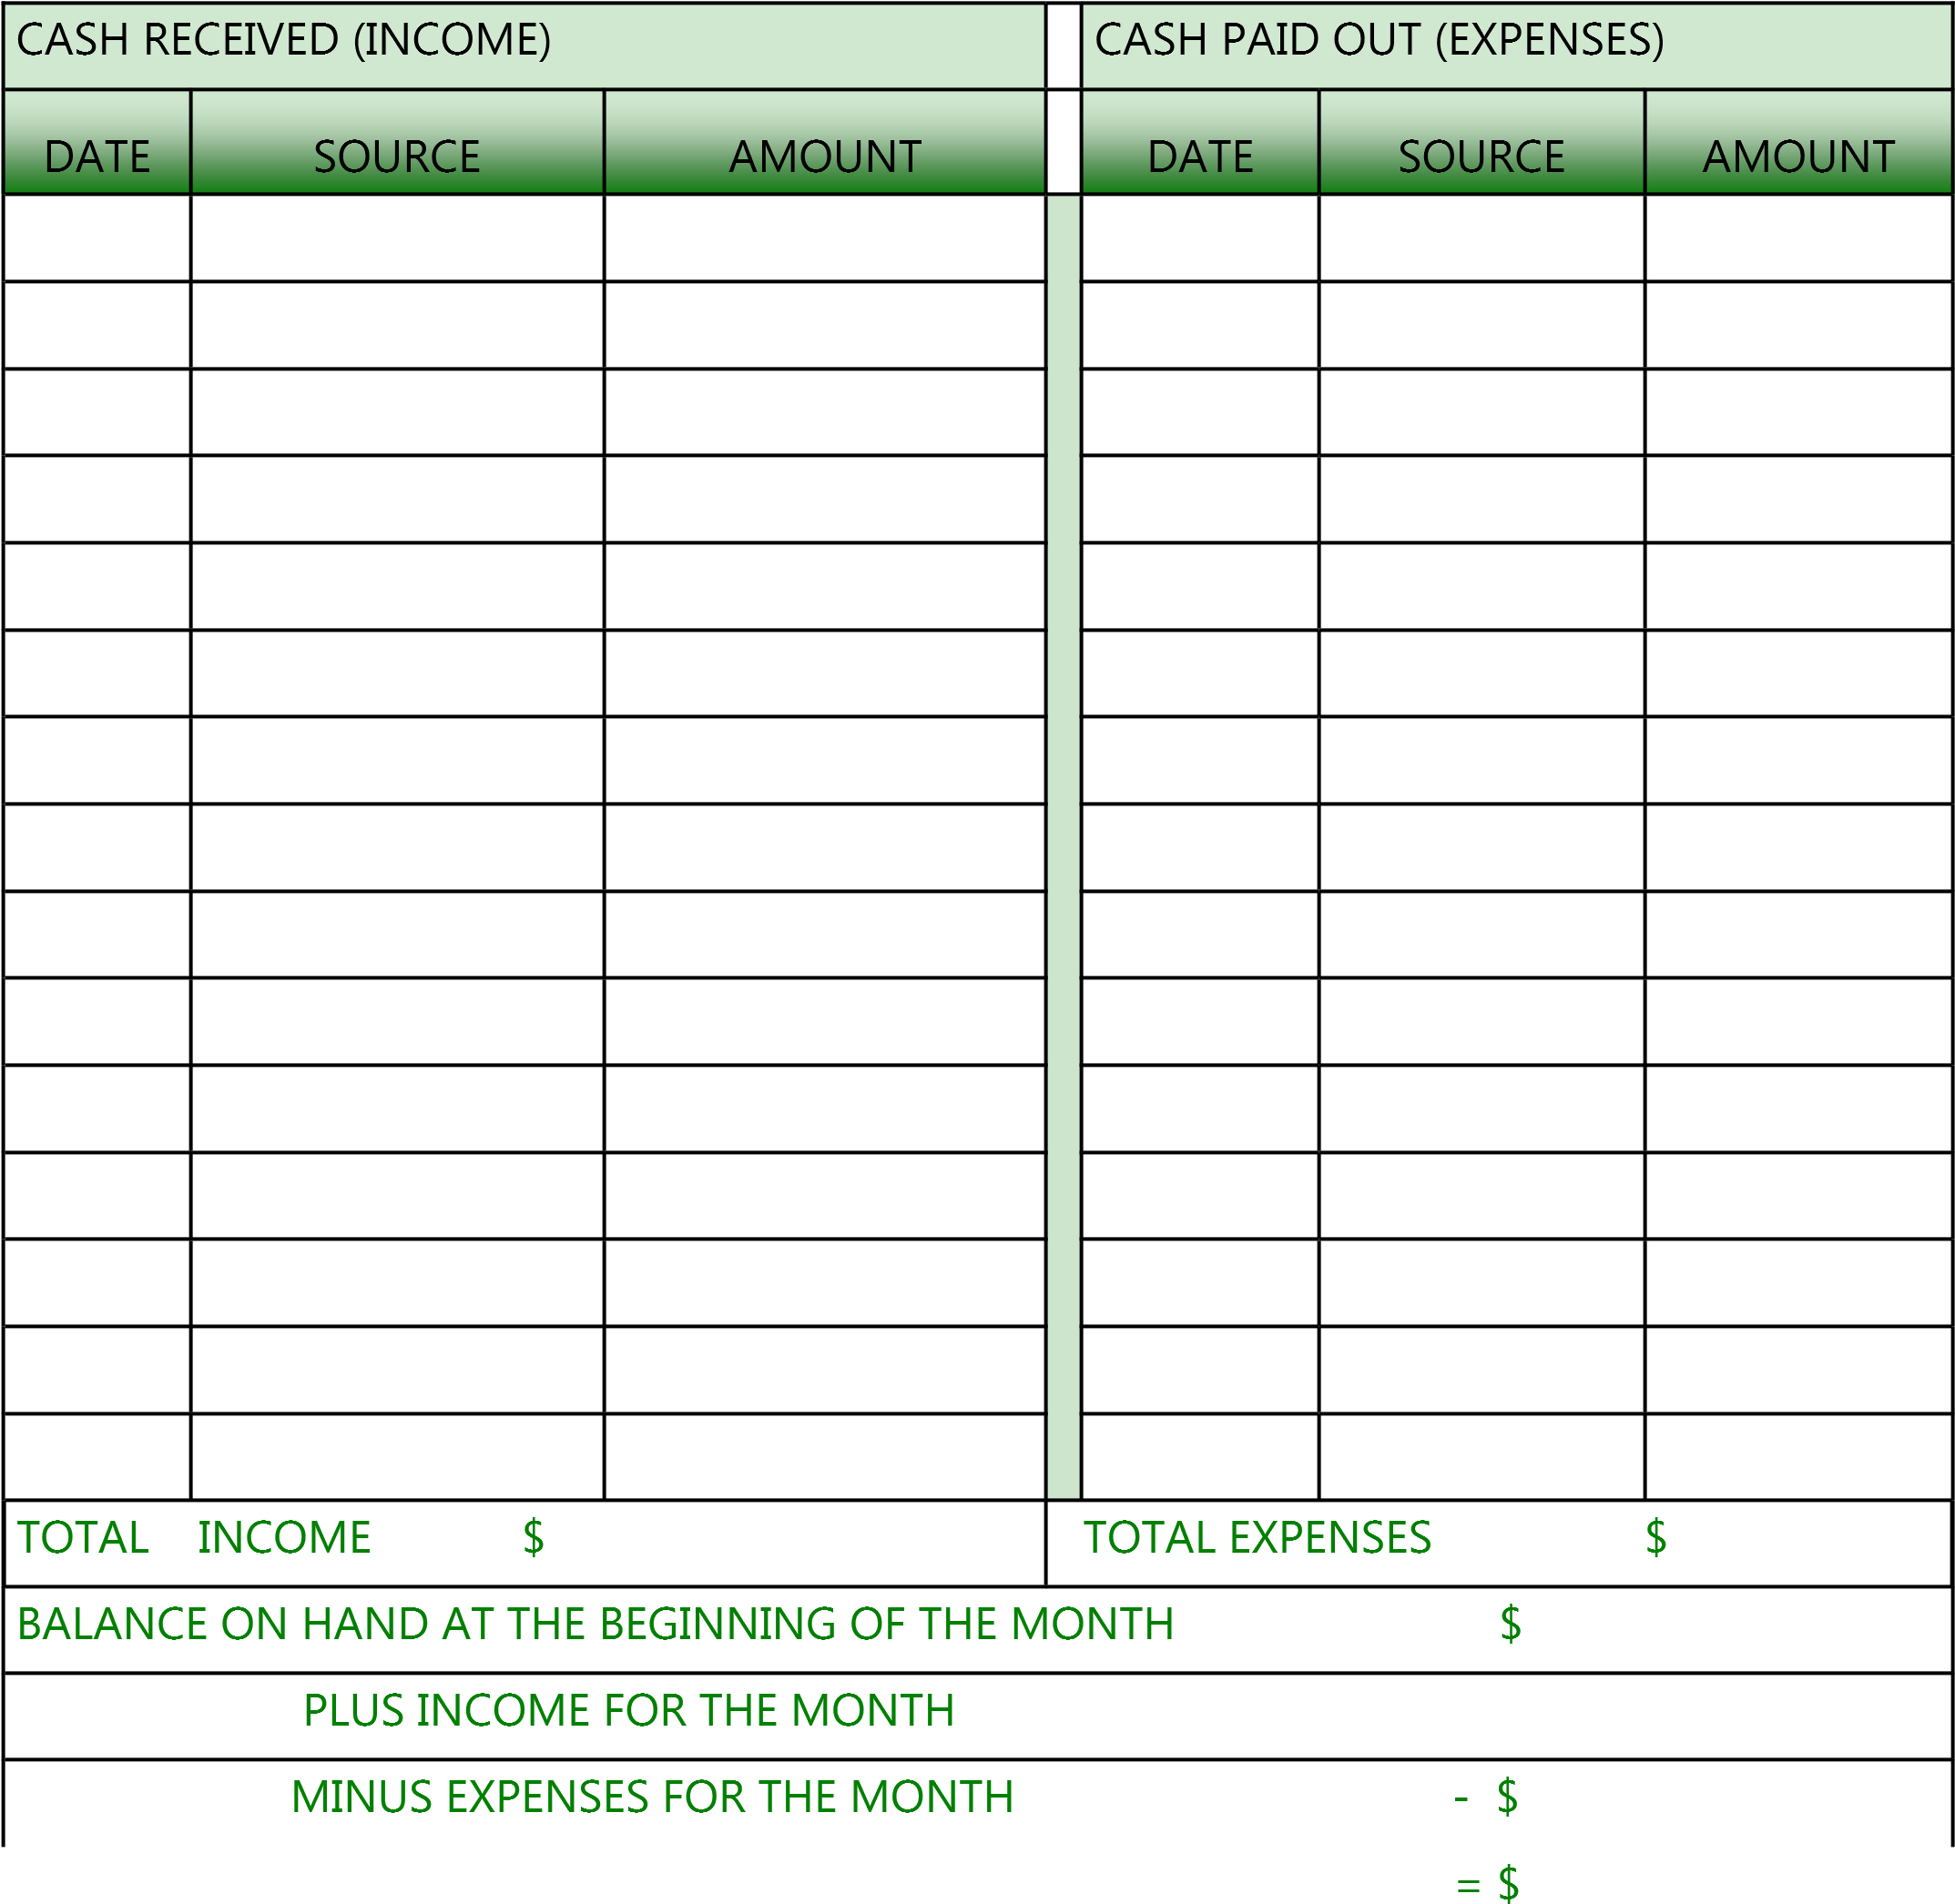+ $

MONTH:

CASH RECEIVED (INCOME) |  |  |  | CASH PAID OUT (EXPENSES)
DATE | SOURCE | AMOUNT |  | DATE | SOURCE | AMOUNT
TOTAL INCOME $ |  |  | TOTAL EXPENSES $
BALANCE ON HAND AT THE BEGINNING OF THE MONTH $
PLUS INCOME FOR THE MONTH +$
MINUS EXPENSES FOR THE MONTH - $
BALANCE ON HAND AT END OF MONTH =$

Date___________

Bank account is in:

_____________________County 4-H Association.

I certify that this Treasurer’s Book contains a correct statement of receipts and expenses of the club and that I have compared my Ledger to the bank statement received from my 4-H Agent or County 4-H Association/Foundation Treasurer.

______________________
Club Treasurer’s Signature

Ledge Records reviewed and approved by:

___________________________________
Club Leader

Glossary of Financial Terms

Account Balance: the total amount of money in an account after adding all money received and subtracting all money paid out from the beginning amount in the account.

Annual 4-H Financial Report : a yearly report that provides a summary of the club’s use of funds during the year. This report should be reviewed by the club leader.

Annual 4-H Financial Summary: A form that states that the Ledger or Report has been compared to the bank statement received from the county 4-H Agent or County Association Treasurer.

Bank Statement: a monthly report from your bank that lists all of the deposits made and funds taken out during the month. This should be compared with your monthly ledger for accuracy. Your statement should come monthly from your County 4-H Association .

Bills: notices of money owed normally sent and received through the mail (examples - phone bill and a bill at a restaurant which is not delivered by mail but given to you by your waiter or waitress).

Budget: a yearly plan of the clubs income and expenses. Income should always equal or be slightly over the amount of expenses you have during the year. This budget should be written by the club treasurer with help from the club’s budget committee, president, and club leader.

Check: a piece of paper given to an account holder (your 4-H club) by the bank so that your club can use it to pay a bill or buy an item; it has the same value as cash. Your county 4-H association will write checks for your club based on your “check request form.”

Club Account: where the club’s money is kept; the club may add money to their account or take some out to spend on activities or projects. A club account must be held with the County 4-H Association.

Deposit: bringing any money the club has earned or received to the bank for the bank to put in the club’s account. The county 4-H Agent or county 4-H association treasurer will make deposits for you.

Endorse: to sign the back of a check in order for it to be deposited into your club’s account. When you endorse the check, you should write “For Deposit Only”, your county 4-H Association’s name and your club’s name. Fill out the “Monies Received form” attach the checks and give them to your county 4-H Agent or county Association Treasurer. .

Estimate: an educated guess on the amount of money the club will need for an activity or project; estimating is used when making the club’s budget to determine how much money the club needs to earn through fundraisers to complete all the projects and activities your club wants to participate in. Please submit immediately to the County 4-H Expense: money that the club spends on projects, activities, or on purchasing items; this amount of money is taken out of the club account by either writing a check or taking cash out of the club account.

Funds or Treasury: the amount of cash available for the club to use on a project or activity; the club’s funds or treasury is usually kept tin a club bank account.

Income: money earned or received by the club from a fund-raiser or donations; this money should be deposited into the club account.

Monthly Ledger: a monthly account of all income and expenses in detail. This should be used as a basis for giving your monthly report at each club meeting.

Receipt: written form recording the amount of money that was received from a fundraiser, club dues, or some other type of income.

REFERENCES:

Texas AgriLife Extension Service. (2014). 4-H Club Treasurer’s Record Book. Retrieved from:
http://texas4-h.tamu.edu/files/2011/12/publications_management_treasurer1.pdf

Michigan State University Extension. (2014). Michigan 4-H “Treasurer’s Record Book. Retrieved from:
http://4h.msue.msu.edu/uploads/files/4H1203_TreasurersRecordBookWeb.pdf

The 4-H Pledge
I pledge…

my Head
to clearer thinking
my Heart
to greater loyalty
my Hands
to larger service
and
my Health

to better living
for my club
my community
my country
and my world
.
Head

Hands

Heart

Health

The HEAD represents:
- Thinking, planning and reasoning.
- Gaining new and valuable knowledge.
- Understanding the whys.
The HEART represents:
- Being concerned about the welfare ofothers.
- Accepting the responsibilities of citizenship.
- Determining the values and attitudes by which to live.
- Learning how to live and work with others.
- Developing positive attitudes.
The HANDS represent:
- Learning new skills.
- Improving skills already known.
- Being useful, helpful, and skillful.
- Developing respect for work and pride in accomplishment.
The HEALTH represents:
- Practicing healthful living.
- Enjoying life.
- Using leisure time wisely.
- Protecting the well being of self and others.
The 4-H Pledge, first adopted in 1927, summarizes
4-H as the four-fold development of youth through the Head, Heart, Hands and Health.
The Florida 4-H Treasurer’s Manual & Record Book was originally published June 2002 and revised September 2009 and November 2011 by Joy Jordan, associate professor and 4-H youth development specialist; Mary Thomas and Tiffany Browning, 4-H project assistants, Department of Family, Youth and Community Sciences, UF/IFAS Extension.
Revised September 2014 by Judith Levings, state 4-H educational design specialist; Ali Baker, state 4-H resource development coordinator; Sarah Hensley, regional specialized 4-H Extension agent II, Central District; and Stacey Ellison, regional specialized 4-H agent, North East District; UF/IFAS Extension 4-H Youth Development Program, Gainesville FL, 32611. Reviewed October 2017.
The Institute of Food and Agricultural Sciences (IFAS) is an Equal Opportunity Institution authorized to provide research, educational information and other services only to individuals and institutions that function with non-discrimination with respect to race, creed, color, religion, age, disability, sex, sexual orientation, marital status, national origin, political opinions or affiliations. For more information on obtaining other UF/ IFAS Extension publications, contact your county’s UF/IFAS Extension office.
U.S. Department of Agriculture, UF/IFAS Extension Service, University of Florida, IFAS, Florida A & M University Cooperative Extension Program, and Boards of County Commissioners Cooperating. Nick T. Place, dean for UF/IFAS Extension.

