Scoring System
Each section of this Record Book will be scored by the judge based on the completeness and accuracy of that section. You must initial the bottom of each page where there is an initial line in order for that page to be counted in your final score. This record book is not included as a part of your overall Member Record Book Score.

Section | Item | Points Possible
Cover | Signatures | 3
I | Plans and Goals | 10
II | Officer Achievements | 12
III | Secretary’s Records (Found in the Secretary’s Manual & Record Book) | 60
IV | Project Pictures | 10
 | Overall Neatness, Accuracy, Grammar & Spelling | 5
 | Total Possible Points for Project Record Book | 100

Ribbon Awards

Blue: 90% - 100%
Red: 80 - 89%
White: 79% - 0%

P a g e |

4H011/4HGCR01
18
707
USC
Florida 4-H
Secretary
Record Book
18
70
USC
7
Reviewed: 01/2022
Table of Contents
Duties of the 4-H Club Secretary ........... 2
Sample Meeting Agenda or Order
of Business ............................................ 2
Club Information Sheet ......................... 3
Committees ............................................. 3
Club Membership Roster ....................... 4
Club Membership Roster ....................... 5
Suggested 4-H Club Goals .................... 6
Standard of Excellence for 4-H Clubs
and Groups ........................................... 7
Club Performance Standards .................. 7
Annual 4-H Club Program & Activity Plan .......................................... 9
Meeting Plan Form ................................ 10
Membership Roll ................................... 11
Meeting Minutes ................................... 12
Secretary’s Monthly Report .................. 24
Sample 4-H Report Card ......................... 24
Secretary’s Annual Report .................... 25
Our Club’s Achievements ...................... 27
Suggested 4-H Club Constitution ........... 28
The 4-H Pledge ...................................... 29
Name of 4-H Club:
County: Club Year: 20 to 20
Leader’s Name:
Secretary’s Name:
Extension Agent: Amber Norris

Dear 4-H Secretary
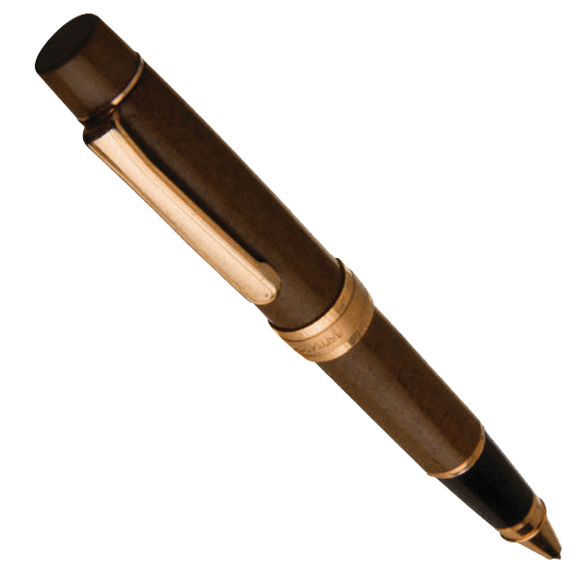
Congratulations on being selected as your 4-H Club Secretary! This is an important position and your good work will help your club to be successful. This book should serve as a good guide for you to follow and outline your club’s goals, plans for the year, as well as keep records of what your club has done.
Here are a few hints to be successful:
- Look through this book and pay careful attention to your duties, the by-laws, and the section for club goals/planning.
- Use this book as a guide and planner, and a way to keep track of your club’s success.
A main part of your job is taking notes during the meeting and keeping up with the correspondence of the club. Make sure to pay careful attention to details when doing your job and you will be sure to be a success.

Duties of the 4-H Club Secretary
- Call roll at the beginning of each meeting (make sure it is alphabetical & up to date).
- Keep records on each member and their participation.
- Keep records and write minutes for each meeting & present minutes at each meeting.
- Handle all correspondence for the club. Correspondence refers to maintaining all the records.
- Keep record all of committee reports.
- Turn in your 4-H Secretary’s Record Book to the 4-H Office at the end of the year.

Sample Meeting Agenda or Order of Business
- Call to Order
- Opening Exercises (songs, pledges, etc.)
  - Roll-Call
- Approval of Minutes
- Reports (Treasure, Council Delegates, Committee)
  - Unfinished Business
  - New Business
- Program (Demonstrations, Slides, Judging Events, Project Talks, Guest Speakers, etc.)
  - Recreation
  - Announcements
  - Adjourn

Club Information Sheet
President:
Vice President:
Secretary:
Treasure: Reporter:
Historian:
Sergeant at Arms: Other Officers:
Club Leaders: Project Leaders:

Activity Leaders:

County Extension Agent:

Committees
Name:
Chairman: Members:

Name:
Chairman: Members:

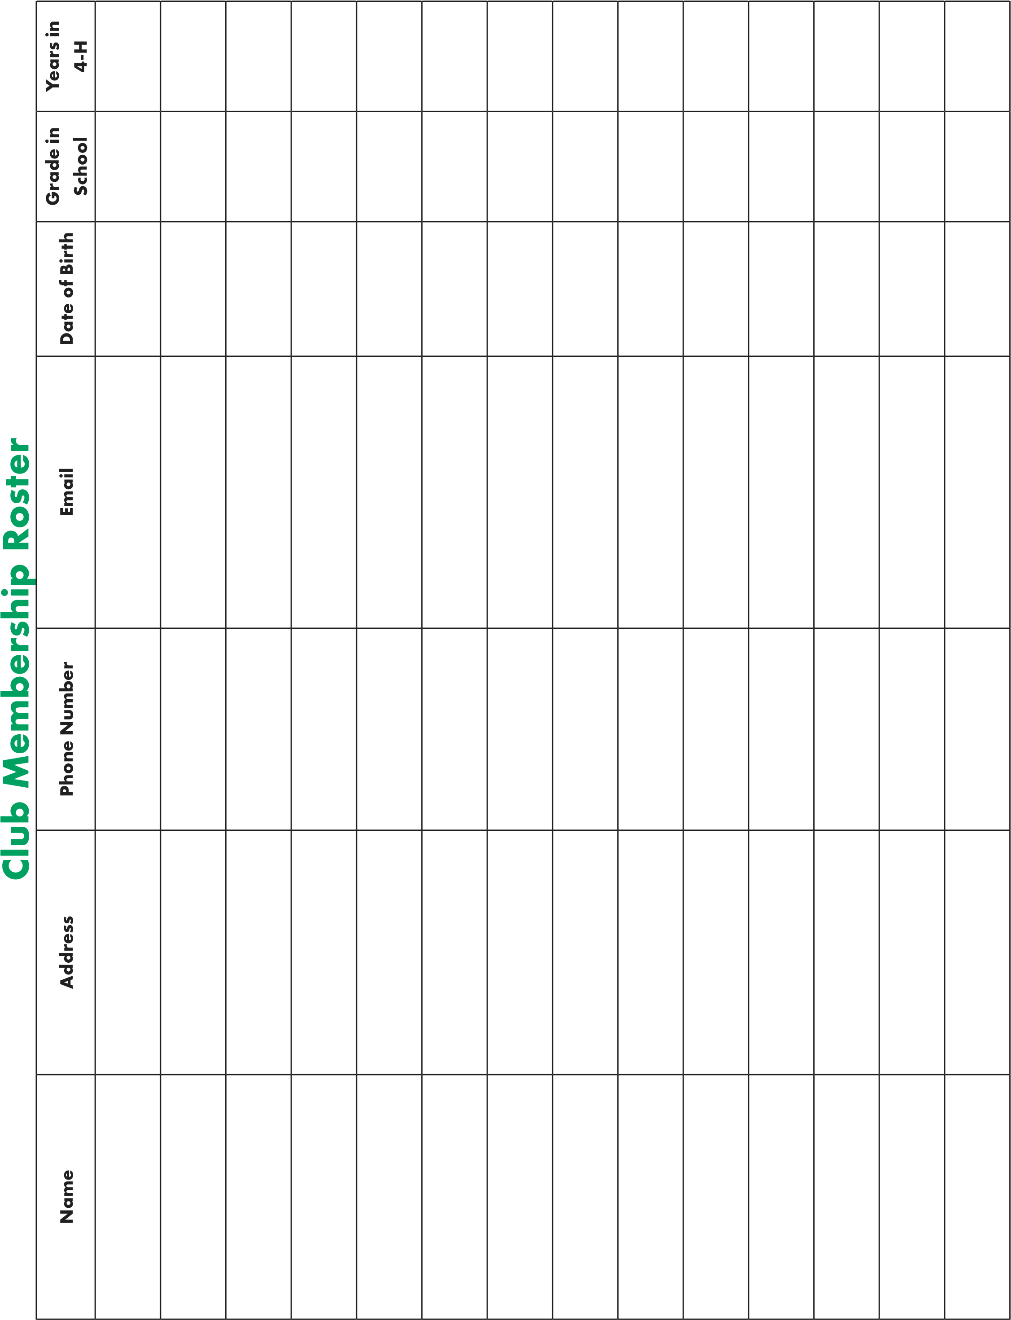
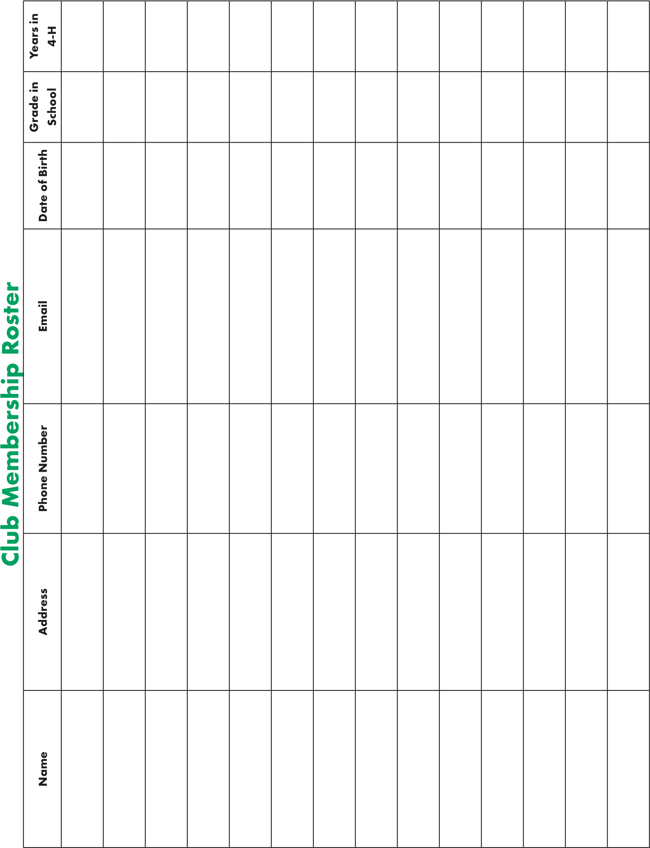

Suggested 4-H Club Goals
For your club to be successful, you should set goals at the beginning of the year. Some goals are general for all clubs, and some goals are specific for your club. Below are suggested goals that your club should meet and space for you to write in your own club goals.
- The yearly program planned and sent to 4-H Extension Agent.
- The club held at least eight regular meetings.
- The average attendance at meetings was at least 75%.
- The club conducted a planned community service activity.
- Every club member presented something at two club meetings.
- The club had entries at county events day.
- At least 75% of members participated in special County 4-H activities.
- The president and council delegate attended all county council meetings.
- Club officers received formal training.

Standard of Excellence for 4-H Clubs and Groups
Check the following Club Performance Standards completed during the 4-H year. Documentation may come from meeting minutes, scrapbooks, photos, newspaper articles, letters, etc.
Club Name: County:
Club/Group President Signature:
Date:
Club Leader:
Date:
Total Number of checked responses for the 20 Excellent Standards:
2–13 Checked of 20 questions = BRONZE Clover Club Award
14–15 Checked of 20 questions = SILVER Clover Club Award
16–17 Checked of 20 questions = GOLD Clover Club Award
18–20 Checked of 20 questions = EMERALD Clover Club Award

Club Performance Standards
1. Club/group had a planned annual program that includes group goals. (Ex: recruit 4 new members; 75% of members will attend camp; all members will choose one county learning activity to attend)
2. Group members were actively involved in planning the group’s annual program.
3. Group selected an area of focus for their annual program. (Ex: health & fitness; environmental science; pet care; community service; intercultural understanding OR Club is represented in the community, by serving on a committee, council or board with adult partners)
4. Group members were involved in implementing the annual program/activities. (Ex: planning and bringing snacks; leading the pledges; calling club members for a group meeting or assignment; presenting a demonstration; organizing a tour; introducing a speaker; leading recreation; teaching others)
5. A calendar for the year was printed and distributed to members, parents, volunteers, and the local Extension Office. (Ex: identify meeting dates, locations, educational programs; special projects; social events; county or district events)
6. All members were invited and at least 75% of group members were involved in at least nine group activities during the year. (Ex: meetings; club tours; recognition event)
- Group officers were elected or appointed and fulfilled their leadership roles.
- Group completed at least one (1) community service project.
- Group completed at least one (1) project that promotes 4-H visibility at the community or county level. (Ex: participating in a community parade; radio interviews during National 4-H Week; project displays in business windows; or doing website development for County Extension office)
- Group has completed at least one (1) project that promotes 4-H visibility at the county, multi-county, district, state, multi-state, national or global level.
- Group recruited at least one (1) project volunteer for at least 75% of the member’s project learning areas.
12. At least 75% of the members made progress toward individual 4-H project goals.
- Group developed a method to communicate with families at least three (3) times per year regarding group activities, education and achievements. (Ex: newsletters; e-mails; calling tree; group activity that includes families)
- Group planned at least one (1) activity to include parents and families in club activities. (Ex: project showcase; skating party; tours; recognition event)
- Members took part in a variety of events and/or meetings beyond the 4-H group level. (Ex: county project workshops; district events; state fair; interstate exchange programs)
- A scheduled recognition event was held for members, volunteers and parents.
17. Club/group planned and implemented at least one multi-club activity. (Ex: doing multi-club community service; several clubs managing a community or county event; conducting a multi-club learning or social event)
- Group members participated in 4-H activities beyond the club level. (Ex: county educational workshops; district events; state fair)
- 4-H club/group consistently had a safety/supervision ratio of 1 adult to 10 youth.
20. The racial/ethnic composition of the club reflects the diversity of the surrounding community. (If club does not reflect the diversity of the community, then successful efforts to contact minority citizens in person, by mail, and through mass media may be used).

Annual 4-H Club Program & Activity Plan
It is important to have a plan of what your club is going to do for the year. Use this sheet to plan the program and activities your club will do each year.
Club Name:
Regular Meeting Time:
Place:

Month | Educational Program | Recreation | Other Activities
September
October
November
December
January
February
March
April
May
June
July
August

Meeting Plan Form
It’s a good idea at the beginning of the year to sit down and make plans for who is going to do what at your 4-H Club meetings throughout the year. You can use this sheet as a planning guide to outline who will have what responsibilities each member will have each month.
Month | Inspiration | Pledges | Introduce Program | Program
September
October
November
December
January
February
March
April
May
June
July
August

Membership Roll
Name | Sept. | Oct. | Nov. | Dec. | Jan. | Feb. | Mar. | Apr. | May | June | July | Aug.

Educational Program/Recreation:

Educational Program/Recreation:

Educational Program/Recreation:

Educational Program/Recreation:

Educational Program/Recreation:

Educational Program/Recreation:

Educational Program/Recreation:

Educational Program/Recreation:

Educational Program/Recreation:

Educational Program/Recreation:

Educational Program/Recreation:

Educational Program/Recreation:

Secretary’s Monthly Report
As club secretary, you conduct correspondence on behalf of your club. A special type of correspondence is the Secretary’s Monthly Report. This is sent to the county Extension office to help Extension agents know what is happening in the 4-H club at the end of the year.
Immediately after each monthly club meeting, fill out the report card. It is encouraged to make several copies of this report card for all your meetings. Continue to keep a record of the report cards in this book.

Sample 4-H Report Card
Dear County Extension Agent(s),
Below is a report of our recent 4-H meeting or activity:
Name of 4-H Club:
Type of meeting or activity:
Date of meeting or activity: Place:
Total present: Members:
Leaders:

Others:

What we did:

Date of next meeting:

Place:

Time:

Name of person making report Title

Secretary’s Annual Report
Name of Club: Date Organized:
1.

How many members were on the club roll this year?

2.

How many regular meetings were held?

•

How many project/workshop meetings were held?

•

What kind were they?

3.

What was the average attendance at club meetings?

•

What percentage of the club’s membership is this?

- What community improvement or service projects did the club participate in?

- Number of club members exhibiting projects during the year?

- How many members completed one or more projects?
• What percentage of the club’s membership is this?
- How many members participated in the following during a club meeting:
Gave a talk or demonstration Lead an activity Presented an exhibit
- How many of your club members participated in the following?
State University County Camp Specialty Camps Achievement Banquet
Fairs or Shows Judging Events Other ( )

- Is the club secretary’s book complete? Is the club treasurer’s book complete?
• Did your club keep a scrapbook?
10.

Did any members, or your club, have a newspaper story printed?

How many?

•

Did members of the club make any radio/television broadcasts?

How many?

•

Did members of the club provide outreach on Social Media?

How many?

11.

Did any member appear on school, community or civic programs pertaining to 4-H Club work?

•

How many occasions and what?

- Outside Speakers
Name of Speaker | Subject
- Project Work
Project | Number Enrolled | Number Completed | Project | Number Enrolled | Number Completed
Aerospace |  |  | Goat (Meat/Dairy)
Agriculture Science |  |  | Healthy Living
Beef |  |  | Horse
Bicycle |  |  | Leadership Development
Cat |  |  | Marine & Aquatic Sciences
Citizenship |  |  | Meat Science
Clothing & Sewing |  |  | Money Management
Cloverbud |  |  | Nature & Outdoors
Communication & Expressive Arts |  |  | Outdoor Adventures
Community Service |  |  | Personal Well-being
Computers |  |  | Pets
Dairy Cattle |  |  | Plants & Gardening
Discovering 4-H |  |  | Poultry
Dog |  |  | Rabbits
Earth Science |  |  | Robotics
Electricity |  |  | Science & Technology
Embryology |  |  | Sheep
Energy |  |  | Shooting Sports
Entomology |  |  | Small Engines
Environment |  |  | Soil, Water, & Land Use
Family & Child Development |  |  | Swine
Food & Nutrition |  |  | Vet Science
Forestry |  |  | Weather & Climate
General Animal Sciences |  |  | Wood Working
General Science |  |  | Workforce Preparation
Geospatial

Our Club’s Achievements

State

National

Suggested 4-H Club Constitution
For additional information regarding club bylaws, please refer to EDIS publication 4H338, Adopting 4-H Club Bylaws https://edis.ifas.ufl.edu/4h338
Article I—Name
This organization should be known as the 4-H Club.

Article II—Purpose
The purpose shall be to enable the members to work in harmony with one another for the best interests of the individual and of the community. Leadership, citizenship, and personal development should be the aim.

Article III—Membership
Any boy or girl between the ages of 8 and 18 years, who is interested in club work and willing to accept supervision by Extension Agents or volunteer leaders, may be considered for membership. The club will determine its membership under the guidelines of the Affirmative Action Programs of the Florida Cooperative Extension Service.
Article IV—Meetings
Meetings should be held regularly according to the needs and desires of the group.

Article V—Officers
Suggested officers: President, Vice-President, Secretary, Treasurer, Recreation Leader, Council Delegate, and Reporter as needed. The President, Vice-President, and Secretary should compose the executive committee. The adult 4-H leaders shall serve as advisors to the Executive Committee.

Article VI—Duties of Officers
The president shall preside at all meetings, appoint all committees, and attend to such other duties as usually pertaining to the office. The Vice-President shall act in the absence of the President. The Secretary shall keep the minutes of the meetings and attend to all correspondences of the club. The Treasurer shall collect and account for all monies of the club and shall pay out money only upon the order of the executive committee. The Reporter shall supply local newspapers with the news. The Recreation Leader shall plan and direct the club’s recreational activities. The Council Delegate shall represent the club at council meetings and report to the club membership.

Head I pledge…
my Head
Heart to clearer thinking my Heart
Hands to greater loyalty my Hands

Health to larger service and my Health
to better living for my club my community my country and my world.
18
707
USC

The 4-H Pledge
The HEAD represents:
- Thinking, planning and reasoning.
- Gaining new and valuable knowledge.
- Understanding the whys.
The HEART represents:
- Being concerned about the welfare of others.
- Accepting the responsibilities of citizenship.
- Determining the values and attitudes by which to live.
- Learning how to live and work with others.
- Developing positive attitudes.
The HANDS represent:
- Learning new skills.
- Improving skills already known.
- Being useful, helpful, and skillful.
- Developing respect for work and pride in accomplishment.
The HEALTH represents:
- Practicing healthful living.

The 4-H Pledge, first adopted in 1927, summarizes 4-H as the four-fold development of youth through the Head, Heart, Hands and Health.
Post a pledge banner at your meeting site. At the end of the first meeting, give everyone a card with the 4-H pledge to take home.
- Enjoying life.
- Using leisure time wisely.
- Protecting the well being of self and others.

This document is 4H GCR 01, one of a series of the Florida 4-H Youth Development Program, UF/IFAS Extension. Original publication date November 2009. Revised October 2018. Reviewed April 2019. Visit the EDIS website https://edis.ifas.ufl.edu for currently supported version of this publication.
Sarah Thomas Hensley, state specialized agent III; and Stacey Ellison northeast regional specialized agent; Florida 4-H Youth Development Program, UF/IFAS Extension, Gainesville, FL 32611.
The Institute of Food and Agricultural Sciences (IFAS) is an Equal Opportunity Institution authorized to provide research, educational information and other services only to individuals and institutions that function with non-discrimination with respect to race, creed, color, religion, age, disability, sex, sexual orientation, marital status, national origin, political opinions, or affiliations. For more information on obtaining other UF/IFAS Extension publications, contact your county’s UF/IFAS Extension office.
U.S. Department of Agriculture, UF/IFAS Extension Service, University of Florida, IFAS, Florida A & M University Cooperative Extension Program, and Boards of County Commissioners Cooperating. Nick T. Place, dean for UF/IFAS Extension.

