August Newsletter

September 2 Virtual Food Challenge Learning Club begins
September 11 Bullfrog Creek – Bingo Night @ Valrico location
September 19 Fishing Club – First Meeting @ Bass Pro
September 24-26 First Executive Board Retreat @ Highlands County
October 2 – 5 Rock Eagle Volunteer Conference @ Georgia
Oct. 30 – Nov. 9 Hillsborough County Fair (11-4 Free entry 4-H Day/Round Robin Judging)
November 15 Youth Officer Leadership Retreat 9:00 - 4:30
April 11 Events Day

Read below for details related to the dates above

________

Monthly Connections

September 15 – adult/youth Connections Kickoff - together in same room
At least one volunteer/leader and two club representatives are strongly encouraged to come to this Hillsborough County Connections. It will be held at the Extension office at 5339 CR 579, Seffner @6:30 in the Conference Room.

Hillsborough County Food Challenge Team practice

Sept 26 Zoom
Sept 29 In person
Oct 17 Zoom
Oct 24 In person
Nov 7 Zoom
Nov 14 In person
Dec 12 In person
Dec 19 In person

Virtual Food Challenge Learning Club – Sign up for club beginning August 15, 2025.

September 2nd
Club Format for all Meetings:
· Pledge
· Screen Etiquette
· Icebreaker
· Presentation
· Hands-on activity
· Reflection
· Next meeting Info
· Supply list will be sent out before each meeting

6:30pm-7:30 pm
Welcome and Food Challenge Overview with Mock Activity

September 16th
6:30pm- 7:30 pm
Cross Contamination/ Problem Solving

September 30th
6:30pm- 7:30 pm
Equipment ID and Safety

October 7th
6:30pm- 7:30 pm
Healthy Alternatives and Substitutions

October 14th
6:30pm- 7:30 pm
Nutrition/My Plate

October 28th
6:30 pm- 7:30 pm
Herbs

November 4th
6:30pm- 7:30 pm
Plating and Garnishing

If you are interested in being on the Hillsborough County Cooking Challenge Team - If you are interested, contact Michelle Williamson at
shellberry@gmail.com

Get Hooked on Fun!
Fishing Club

Sign up for club

Are you a youth with a passion for the outdoors, a love for learning, and a desire to connect with other amazing young people? Then cast your line with the
PMH Fin-atics Clovers 4-H
group! We're thrilled to announce a brand-new multi-county initiative that brings together 4-H members from
Martin, Polk, and Hillsborough Counties
for an unforgettable year of aquatic adventures and educational experiences.
What is the PMH Fin-atics Clovers 4-H all about?
This exciting collaboration is designed to provide hands-on learning and incredible memories, all while fostering a love for fishing, marine science, and the great outdoors. Each participating county will be hosting a minimum of three unique learning experiences throughout the year. Imagine exploring different ecosystems, learning new fishing techniques, understanding local marine life, and developing valuable life skills – all with your fellow 4-H members!
Hillsborough County 4-H: Your Local Kick-Off!

For our Hillsborough County 4-H members, get ready to jump right into the action with these exciting local learning experiences:
- Kick-Off Meeting: September 19th at 5:30 PM! Join us at Bass Pro Shop, located at 10501 Palm River Rd, Tampa, FL 33619, for our inaugural meeting! We'll kick things off with an engaging session focused on the fascinating world of fish. We'll be observing fish mouth parts to understand how they feed and exploring the concept of fish depth and why it matters to anglers.
- October & November Meetings: Topography & Tackle! Our meetings in October and November will dive deeper into essential fishing knowledge. We'll be focusing on topography – understanding the underwater landscape and how it influences fish behavior. We'll also spend time on tackle, learning about different types of fishing gear, equipment maintenance, how to use them effectively, and what's best for various fishing scenarios.
- Your Own Zebco Combo! To get you started on your fishing journey, each Hillsborough County 4-H member participating in this program will receive their very own Zebco Combo courtesy of Bass Pro partnership – perfect for putting your new skills to the test!

Mark Your Calendars for These Unforgettable Events if you choose to participate!
We've got some incredible events planned that you won't want to miss:
- December: Charter Fishing Trip in Martin County! Get ready to set sail and experience the thrill of offshore fishing! We'll be heading to the beautiful waters of Martin County for an exciting charter fishing excursion. Learn from experienced captains, reel in some impressive catches, and make memories that will last a lifetime.
- Family Fishing/Camping Weekend at Camp Cloverleaf! Date TBD - Pack your tents and your fishing gear! There is a limited number of cabins and even a few RV hookups. We're organizing a fantastic family-friendly weekend at Camp Cloverleaf. This is a wonderful opportunity to bond with your family, hone your fishing skills, enjoy the tranquility of nature, and connect with other 4-H families from across the counties.

Affordable Fun for Everyone!
We believe these incredible experiences should be accessible to all. We are working on getting the cost of the charter and camp down as low as possible.

Ready to Dive In?
Don't miss out on this incredible opportunity to learn, explore, and connect with other youth who share your interests. The PMH Fin-atics Clovers 4-H is more than just a club; it's a community where friendships are forged, skills are developed, and memories are made.
Contact

amber.norris@ufl.edu

- Hillsborough County 4-H Extension Agent today to learn more! Let's get "fin-atical" about 4-H!

_____________________

Youth Leadership Retreat

All club officers are welcome! We strongly encouraged each club to send at least two officers to learn about creating a sense of belonging during club meetings, conducting effective club meetings, crafting an elevator speech, and refining their communication skills. Youth will leave with lots of ideas and resources to build a successful club year.

November 15, 2025
9:00 am - 4:30 pm - Lunch will be included
location TBD
______

Southern States 4-H Volunteer Conference - October 2 - 5, 2025

What - The 4-H Volunteer Conference is open to 4-H volunteers (and paid staff) from across the world. Hosted by the 4-H Volunteers Conference of Southern States, a team of 4-H volunteers and staff plan the event each year. The conference is hosted onsite at ?Rock Eagle 4-H Center and has virtual components, including a library of recorded content. We welcome you to our community and hope you'll join us as we thrive in 2025

Who – any volunteer – if you are a new leader, you will learn sooooo much.

Where - Rock Eagle 4-H Center in Eatonton, Georgia

How much - Registration Costs
Full-time Registration (Single Occupancy) $490
includes all conference onsite activities and virtual recordings; single occupancy lodging with private room and bath; meals from dinner Thursday - breakfast Sunday; conference swag and promotions

Full-time Registration (Double Occupancy) $400
includes all conference onsite activities and virtual recordings; double occupancy lodging with shared room and bath with requested roommate (roommates must match); meals from dinner Thursday - breakfast Sunday; conference swag and promotions

If you think you would like to attend, email amber.norris@ufl.edu. Grants are available in the county. Trying to get an idea who would like to go. Trying to plan transportation.

Hillsborough County Fair entry deadlines – check individual livestock species
October 1 for Speech Contest Event,
Arts and Crafts Online: https://hillsborough.fairwire.com/ July 1 – Oct 1, 2025 • Mail: Hillsborough County Fair, PO Box 100, Sydney, FL 33587 – Postmarked by Oct 1, 2025 • Walk-up entries will be allowed during the times specified in the Acceptance of Entries section.
Also Walk-ups must have completed the exhibitor’s entry form and will receive one free admission ticket to the fair (per person not per item).
Scholarship Opportunities at the 2025 Hillsborough County Fair! 🐄🐖🐑
Deadline for application: October 1, 2025. $1,500 in scholarships available
Are you a livestock exhibitor at the Hillsborough County Fair? Don’t miss out on the chance to apply for scholarship opportunities available exclusively to our dedicated youth exhibitors!
💰 Scholarships are awarded to recognize hard work, leadership, and involvement in agriculture.
👉 Click here to learn more and apply: https://www.hillsboroughcountyfair.com/p/fair/livestock

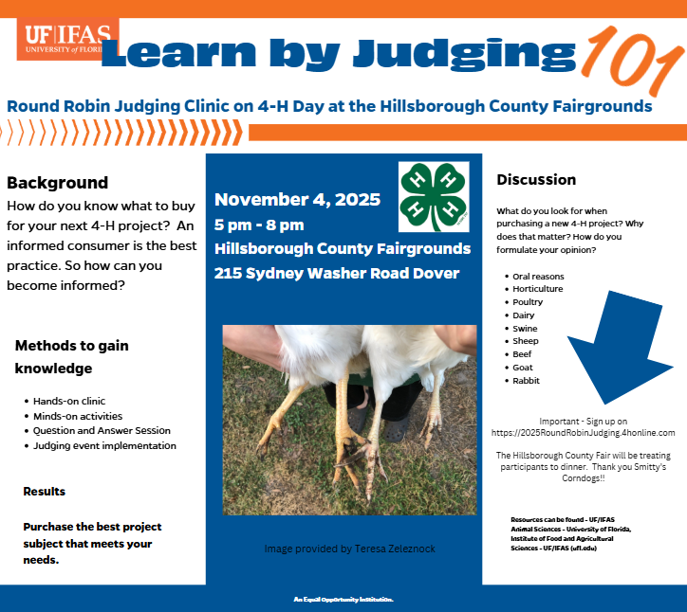

We have an upcoming Extension program that your 4-H members and club leaders may be interested in. This program will cover the basics of a herd health plan (not just vaccines), plus how to select and use vaccines/medications properly. Our Extension veterinarian will be one of the presenters and will be able to answer vaccine and health questions. Plus, registration comes with supper, networking, and educational materials!
Tuesday, September 16, 2025, from 6:00–8:00 PM at the Hillsborough County Cattlemen’s Building (6404 S County Rd 39, Plant City, FL 33567). Invite your friends, family, and neighbors for a brisket supper and an educational seminar on herd health for your cattle herd.
This program will dive into the key components of a herd health plan and proper vaccine management to maximize herd health.
We’re excited to welcome Dr. João Bittar with the UF/IFAS College of Veterinary Medicine, who will cover:
- Vaccine protocols and cow management
- The different types of vaccines and when to use each type
- How to prevent vaccine failure
- Practical strategies to manage herd health for better animal health, efficiency, and performance
Event Details
📅 Date: Tuesday, September 16, 2025
🕕 Time: 6:00–8:00 PM
📍 Location: Hillsborough County Cattlemen’s Building
6404 S County Rd 39, Plant City, FL 33567
💲 Registration: $25 (ticket sales end Friday, September 12)
🔗 Register here: 2025herdhealth.eventbrite.com
Don’t miss this chance to enjoy a great meal, connect with fellow producers, and take home strategies to improve your herd’s health and profitability.
Please share with neighbors and fellow producers who could benefit. We look forward to seeing you there!

____
Football season is almost here and Florida 4-H has TWO ticket offers to share this season:

8/30 v LIU: 352 Community Day: www.gofevo.com/event/Florida42
- Portion of each ticket sold benefits the Florida 4-H Foundation

9/6 v USF: 4-H Day at the Swamp: tinyurl.com/4Hswamp25
- Includes access to a 4-H Tailgate as part of UFAA's Gator Nation Tailgate

Please share this offer with family and friends!
- 352 Community Day Facebook Post
- 352 Community Day LinkedIn Post
- 4-H Day Facebook Event
- 4-H Day LinkedIn Post
Ethics for State Fair
2025/2026 YOUTH LIVESTOCK SHOW ETHICS AND ANIMAL CARE WORKSHOP - Google Docs

Association grant

Member grant link:
Event Registration - Google Forms

Volunteer grant link:
Event Registration - Google Forms

HILLSOBORUGH FOUNDATION GRANT LINK
Hillsborough County 4-H Youth Foundation & Volunteer Grants Program - Hillsborough County 4-H Foundation

