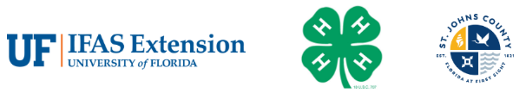
St. Johns County 4-H Clover Award Application
INTERMEDIATES (11-13 YEARS OLD)

Activities during June 1, 2025-May 31, 2026
Clover Award Application Due by 4:00PM on June 1, 2026
Award Level Youth Applying for: Bronze Silver Gold Emerald
4-H OFFICE USE ONLY: Award Level Received Bronze Silver Gold Emerald

Name: ____________________________________________________ 4-H Age: ________________
Club(s):___________________________________________________________________________
_________________________________________________________________________________
Activity | Completion Date | Required Signatures
Project Report*
Attend 2/3 Club Meetings*
Club Speech or Demonstration*
Wildcard/Extra Credit (Attach copy)
Serve on a Committee or Hold Office
GOLD (G)
Participate in Service Projects
BRONZE (B)
(G)
Lead Service Project (Attach Report)
EMERALD (E)
Teach Club Activity
SILVER (S)
Activities Participated In
(B)
(B)
(S)
(G)
(E)
*Cannot be substituted by a Wild Card.

Activity | Completion Date | Required Signatures
Participated in Competitions/Exhibitions
(B)
(S)
(G)
(G)
(E)
Attend District or Higher Event
(G)
(E)
Completed Record Books**
(B)
(G)
“Can One 4-H’er Really Make a Difference?”
(G) Essay (Attach Copy)
Write a Thank You note to Your Club Leader or 4-H Office
(B)
One Parent/Guardian Support Activity
(B)
** Cannot be substituted by a Wild Card

Parent Signature: _________________________________________ Date: ____________________

Participant Signature: _____________________________________Date: ____________________

4-H OFFICE USE ONLY
Comments:

