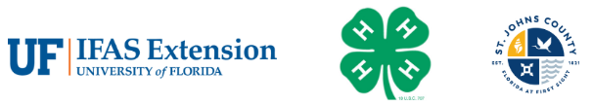
St. Johns County 4-H Clover Award Application
JUNIORS (8-10 YEARS OLD)

Activities during June 1, 2025-May 31, 2026

Clover Award Application Due by 4:00PM on June 1, 2026
Award Level Youth is Applying for: Bronze Silver Gold Emerald
4-H OFFICE USE ONLY: Award Level Received: Bronze Silver Gold Emerald
Name: ____________________________________________________ 4-H Age: ________________
Club(s): ___________________________________________________________________________
_________________________________________________________________________________
Activity | Completion Date | Required Signatures
Project Report*
Attend 2/3 Club Meetings*
Club Speech or Demonstration*
Wildcard/Extra Credit (Attach copy)
Participate in Service Projects
BRONZE (B)
EMERALD (E)
Teach Club Activity
SILVER (S)
Activities Participated In
(B)
(S)
(G)
(E)
Participated in Competitions/Exhibitions
(B)
(S)
(G)
(E)
*Cannot be substituted by a Wildcard.
Activity | Completion Date | Required Signatures
Completed Record Books**
(B)
(G)
“My 4-H Experience”
(G) Poster (Submit with Application)
Write a Thank You note to Your Club Leader or 4-H Office
(B)
One Parent/Guardian Support Activity
(B)
**Cannot be substituted by a Wild Card

Parent Signature: __________________________________________ Date: ____________________

Participant Signature: _____________________________________________Date: ______________

4-H OFFICE USE ONLY

Comments:

